Contents

53. Responsive Grid – Part 1 2

54. Responsive Grid – Part 1 - Enabling responsive Emulator 4

55. Responsive Grid – Part 3 – Activate Layout mode 7

56. Breadcrumb component 12

57. Modify Navigation button 14

58. Create Custom Error Handler 18

59. Build an AEM 6.4 project using Maven Archetype 13 20

60. Build and Deploy project in AEM 6.4 23

61. AEM project structure and importing project in Eclipse IDE 28

# 53. Responsive Grid – Part 1

1. Responsive Grid is also called as layout container.
2. It is basically a dynamic response grid or dynamic layout container.
3. It is same as parsys but it allows you to position the component within the responsive grid. So, it provides extra benefit compared to parsys.
4. Hence, it is highly recommended to use Responsive Grid over Parsys.
5. It is defined under CRX/DE path “/libs/wcm/foundation/component/responsivegrid”

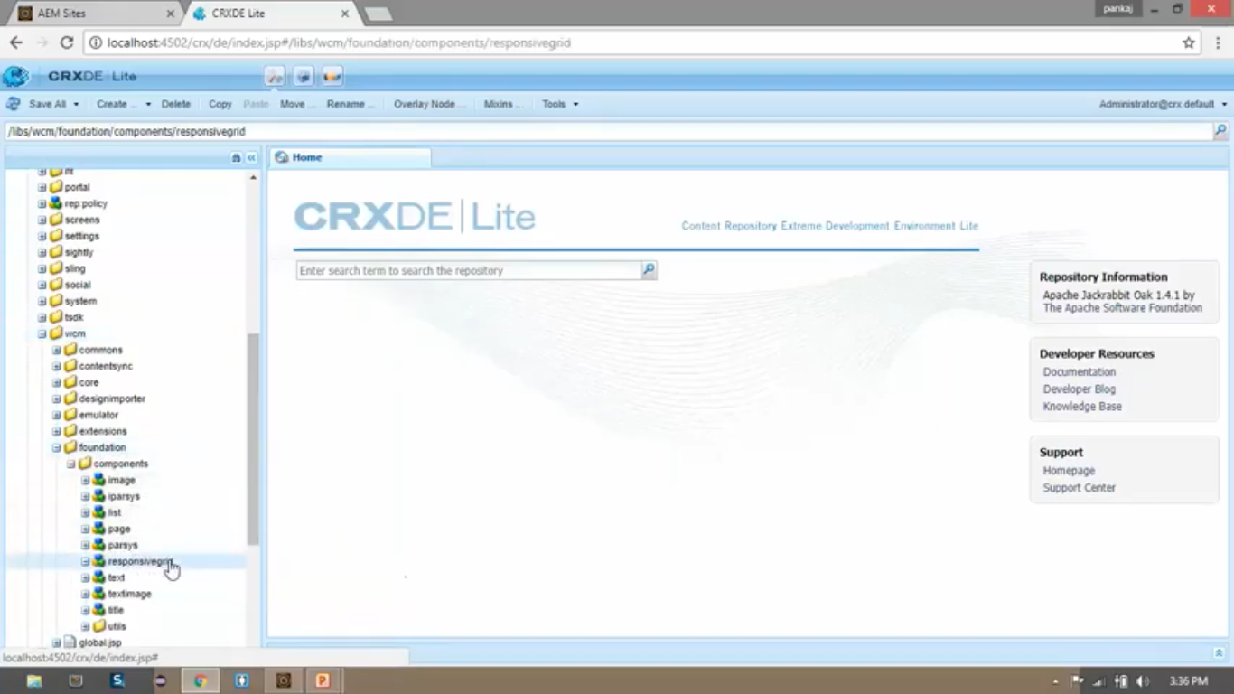

So let’s add this Responsive Grid to our page at the place where text “Responsive Content Area” is shown.

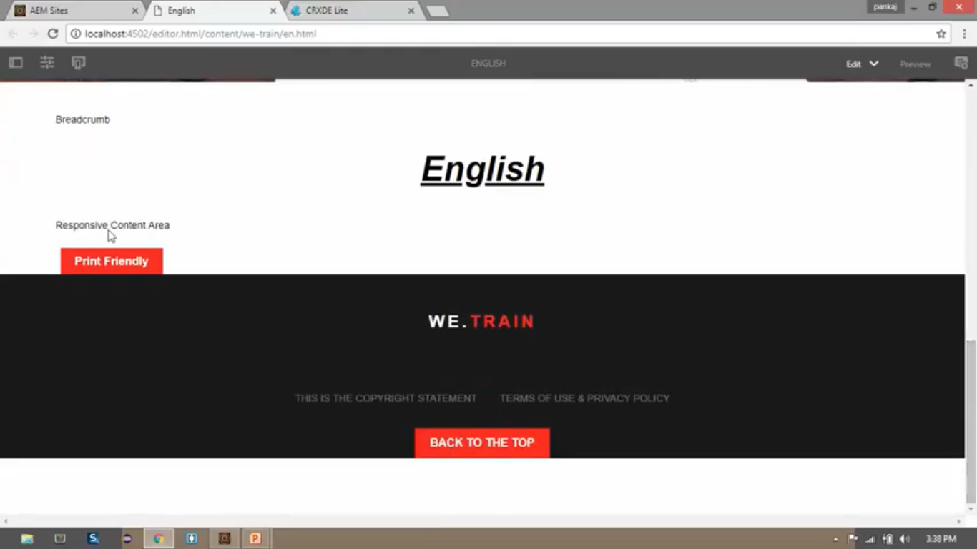

1. Open file from CRX/DE path “/apps/training/components/structure/contentpage/body.html”
2. Replace code present at line number 25 with below mentioned code.

**Before (code):**

<div> Responsive Content Area </div>

**After (code):**

<div data-sly-resource = “${‘responsivegrid’ @ resourceType = ‘wcm/foundation/components/responsivegrid’ }”> </div>

1. Open English page <http://localhost:4502/content/we-train/en.html>
2. Open page in “Edit mode” by selecting “Edit” option from dropdown at top-right corner of the toolbar.

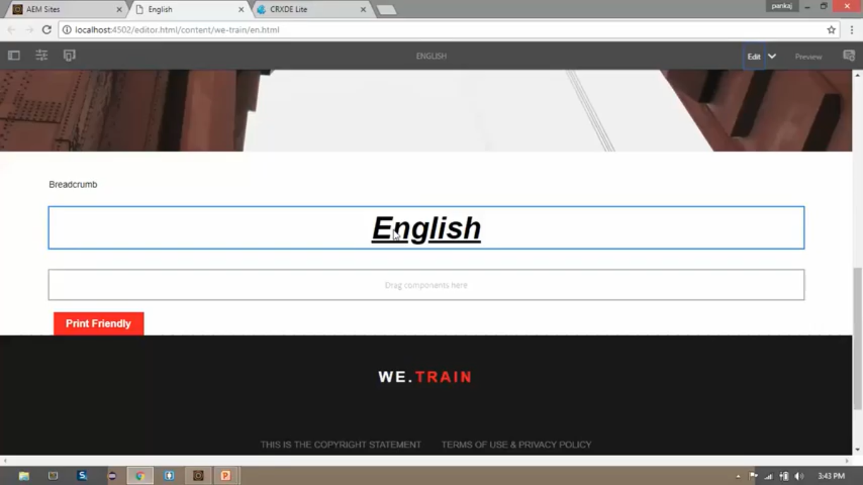

1. Here you can see (above image) that our text Responsive Grid component.
2. This Responsive Grid looks similar to Parsys component but it provides extra benefit for responsive grid.

# 54. Responsive Grid – Part 1 - Enabling responsive Emulator

1. Go to CRX/DE. Right click on “/apps/training” --> Create --> Create Folder --> Name it as “**config**”.
2. Click on “**Save All**” button.
3. Go to OSGI console <http://localhost:4502/system/console/bundles>
4. Click on **OSGI** menu --> select **Configuration** option --> search on page (ctrl + F) with “mobileemulator”.
5. Click on the first record having “mobileemulator”.

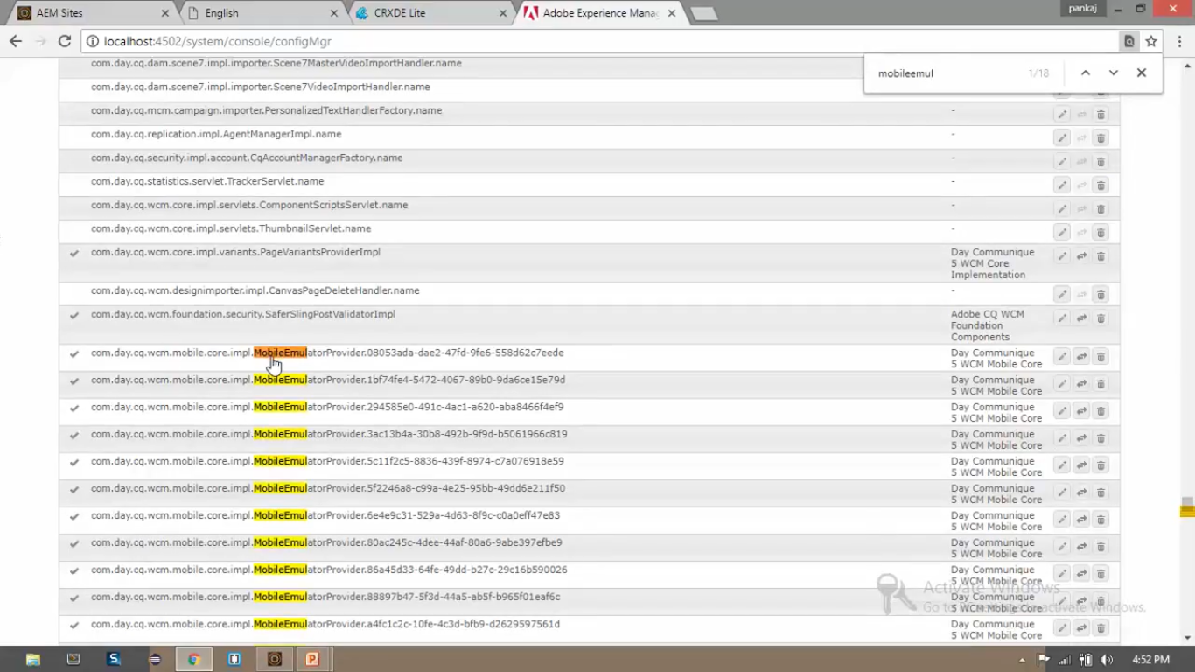

1. Copy the **path** from field “**Persistent Identity (PID)**”.

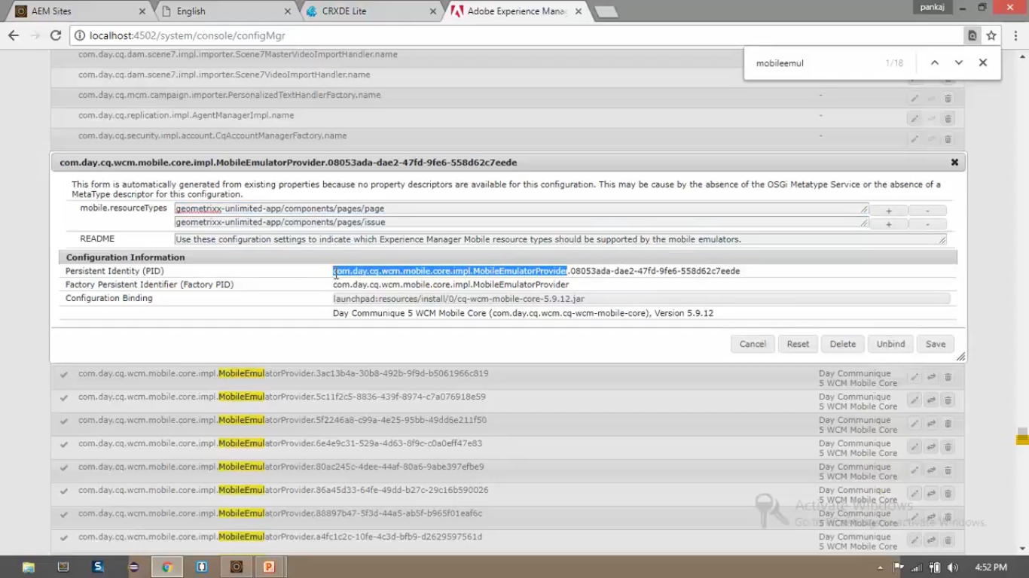

1. Go to CRX/DE. Right click on “/apps/training/config” --> Create --> Create Node --> Set below values
2. Paste the copied value in field “Name”. Append our project name with hyphen (-training)

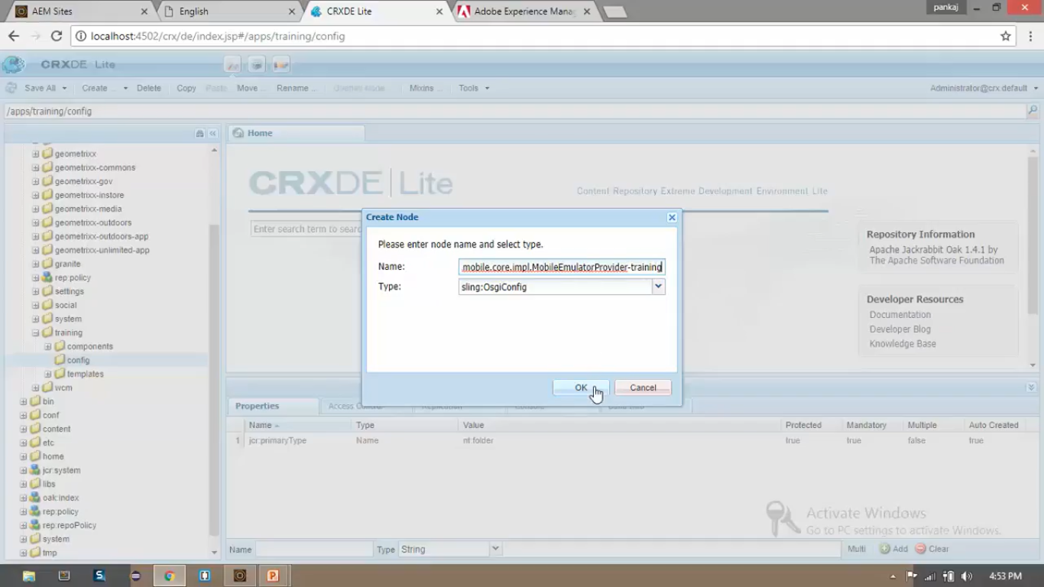

1. Add a property to this newly created node from properties pane

|  |  |  |
| --- | --- | --- |
| **Field Name** | **Field Type** | **Field Value** |
| client.resourceTypes | String | Training/components/structure/contentpage |

1. Click on “Save All” button.
2. Go to CRX/DE path “/content/we-train/jcr:content”.
3. Add property to this node

|  |  |  |  |
| --- | --- | --- | --- |
| **Field Name** | **Field Type** | **Field Value** | **Action** |
| Cq:deviceGroups | String | /etc/mobile/groups/responsive | Click on Multi (to make it string array type) |

1. Click on “**Save All**” button.
2. Open English page <http://localhost:4502/content/we-train/en.html>
3. Click on “**Preview”** button to open page in **Preview Mode.**

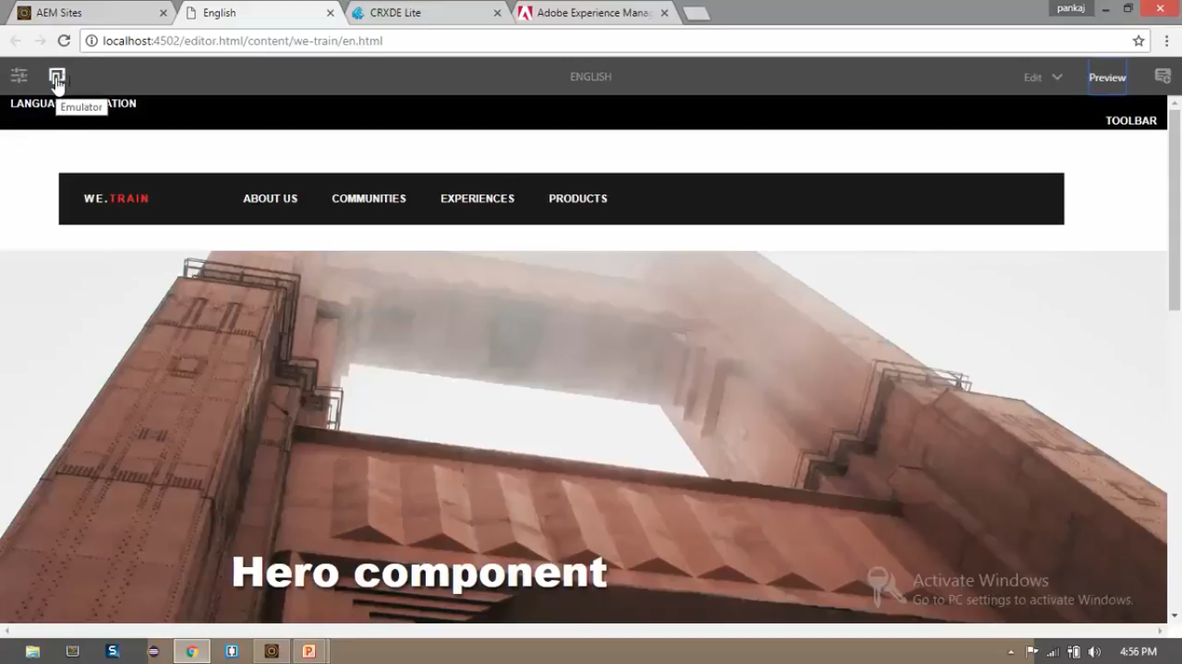

1. You can see (above image) that highlighted icon is the “**Emulator**” icon.
2. If you click on **Emulator** icon, you can choose among various devices.

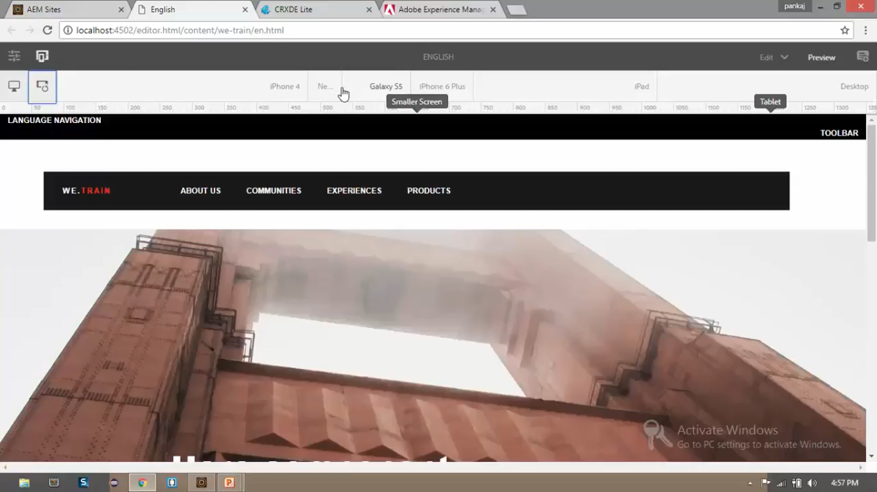

1. You can see (above image) that you can choose various devices such as desktop or mobile. If you choose **mobile**, then you can additionally choose iPhone (4/5/6/7/8/X), iPad, Nexus, Galaxy S5, Desktop.
2. You can also select Portrait or Landscape display mode to see web site pages in different angles.
3. If you select iPhone 6 (below image), this is how our web site page will look like in iPhone 6.

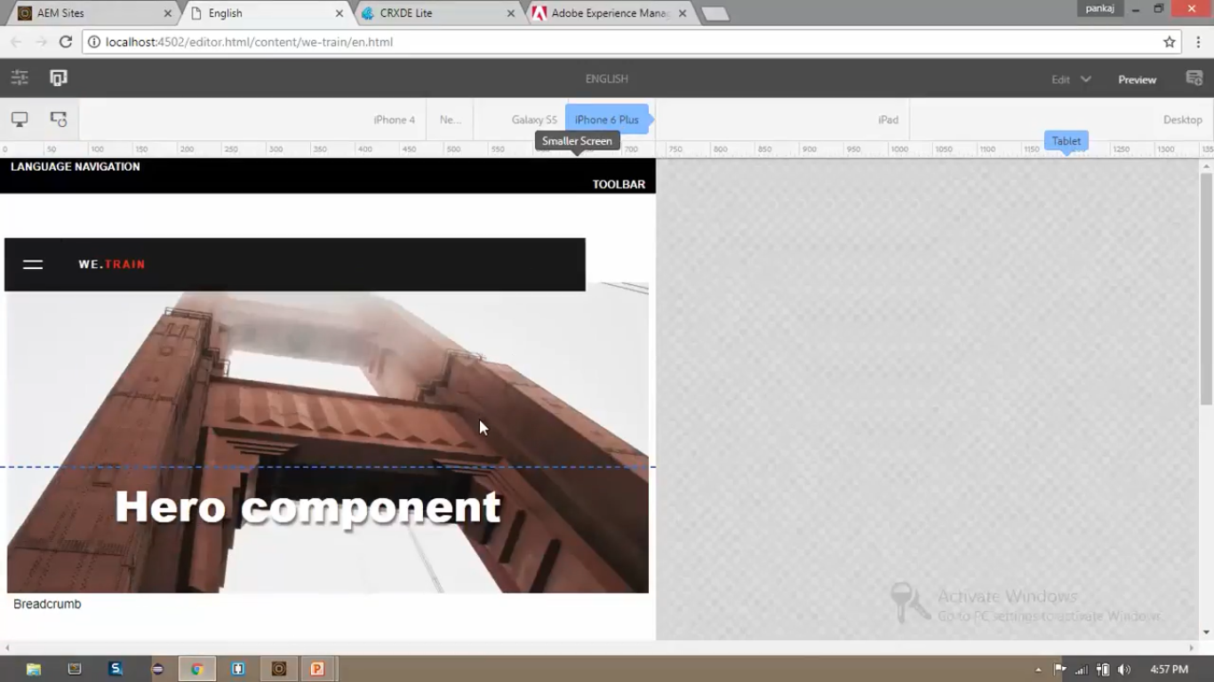

1. So, this multi-screen experience helps you to optimise your CSS further.

# 55. Responsive Grid – Part 3 – Activate Layout mode

1. To configure layout of responsive grid we need to use Layout mode.
2. Using this layout mode, you can resize the components using the blue dots.
3. Let’s see how to activate layout mode.
4. Go to CRX/DE. Copy node “/content/geomatrixx-media/en/jcr:content/cq:responsive”.
5. Paste this copied node to path “/content/we-train/jcr:content”
6. Click on “Save All” button.
7. You can see that copied node contains breakpoints for phone and tablets. Check their properties.

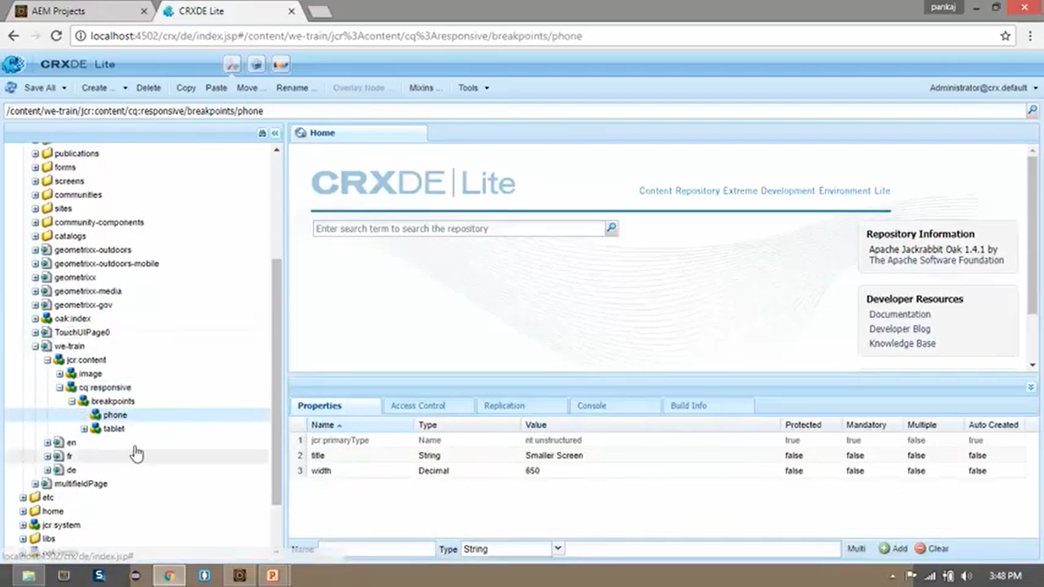

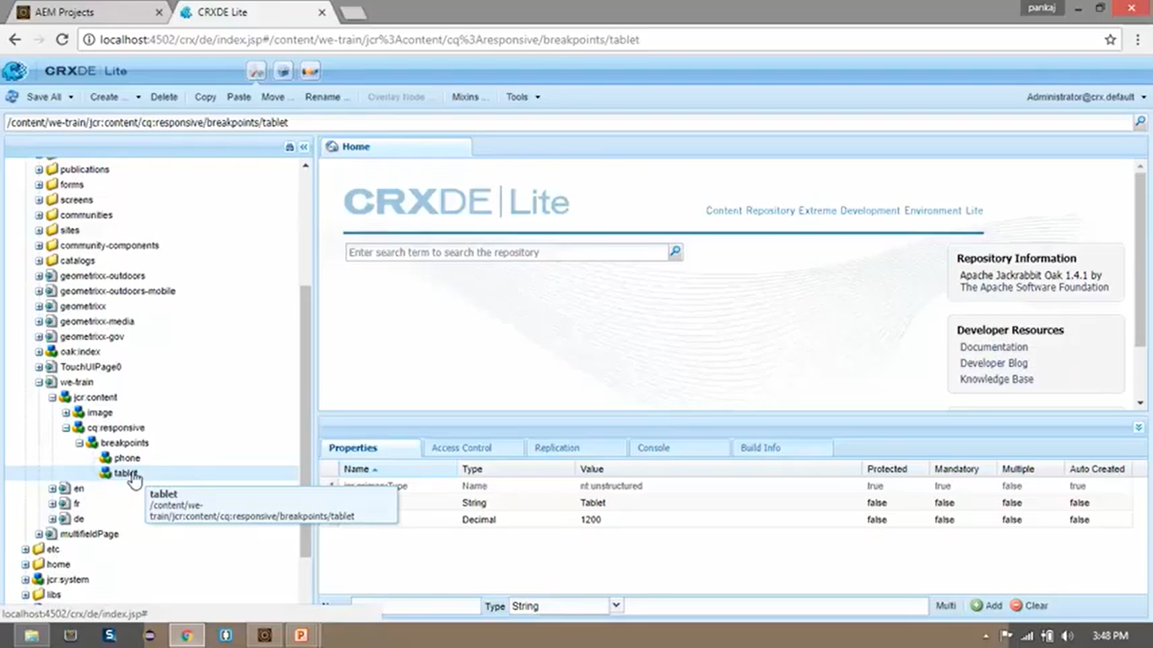

1. You can see (in below image) that we have activated **Layout mode** successfully.

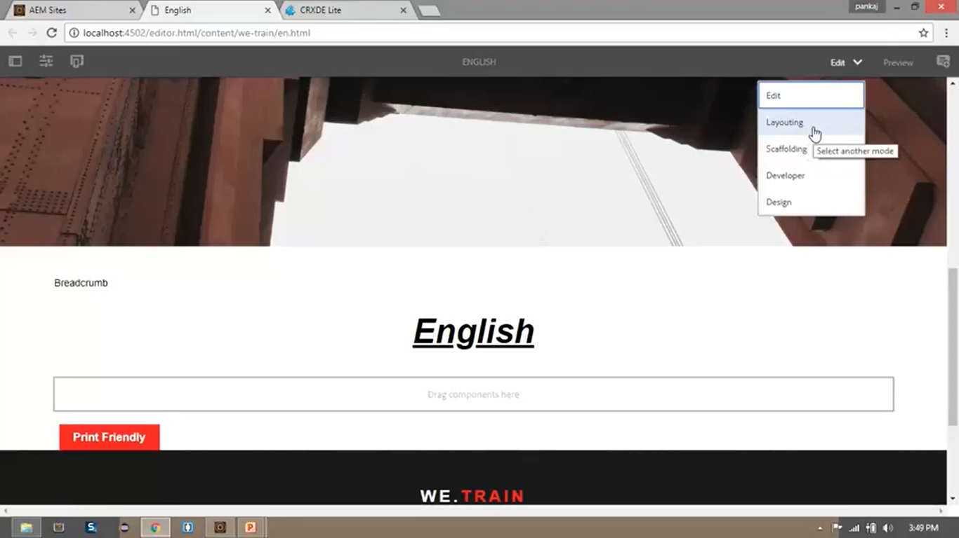

1. GO to CRX/DE path “/etc/designs/training/clientlib-site/css/grid.less” (less --> Leaner Style Sheet)
2. Open English page <http://localhost:4502/content/we-train/en.html>
3. Open page in “Design mode” (select Design from dropdown present at top right corner of the Toolbar)
4. Click in “Edit icon” on “Drag components here” section.
5. Check on “General” checkbox from Allowed Components field.

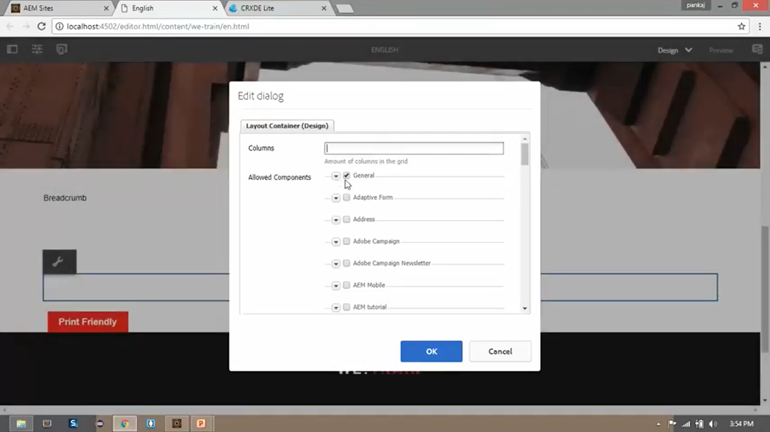

1. Open page in “Edit mode” (select Design from dropdown present at top right corner of the Toolbar)
2. Click on “Drag component here” section to Insert New Component. Select “Text” component.

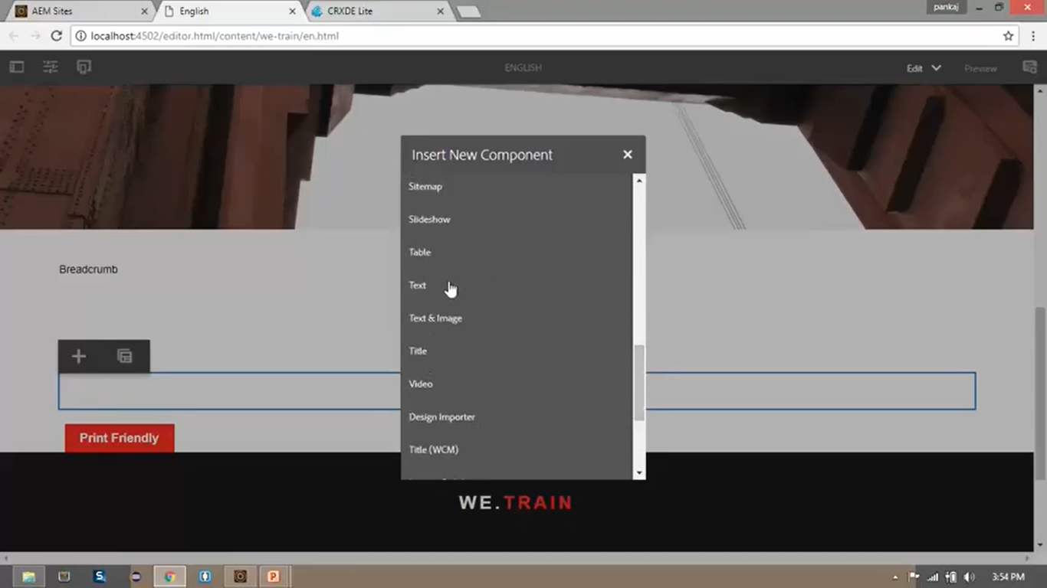

1. Click on this newly added text component to add some random text.

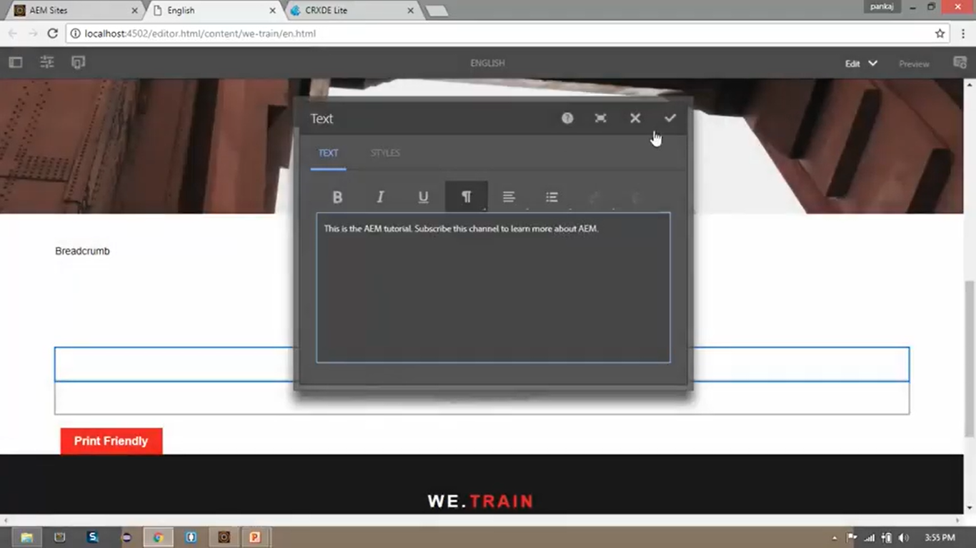

1. Open page in “Layout mode” (select Design from dropdown present at top right corner of the Toolbar)
2. Click on this newly added text component to resize the component.
3. Click and drag the extreme endpoints (blue dots) of this newly added components to resize the component.

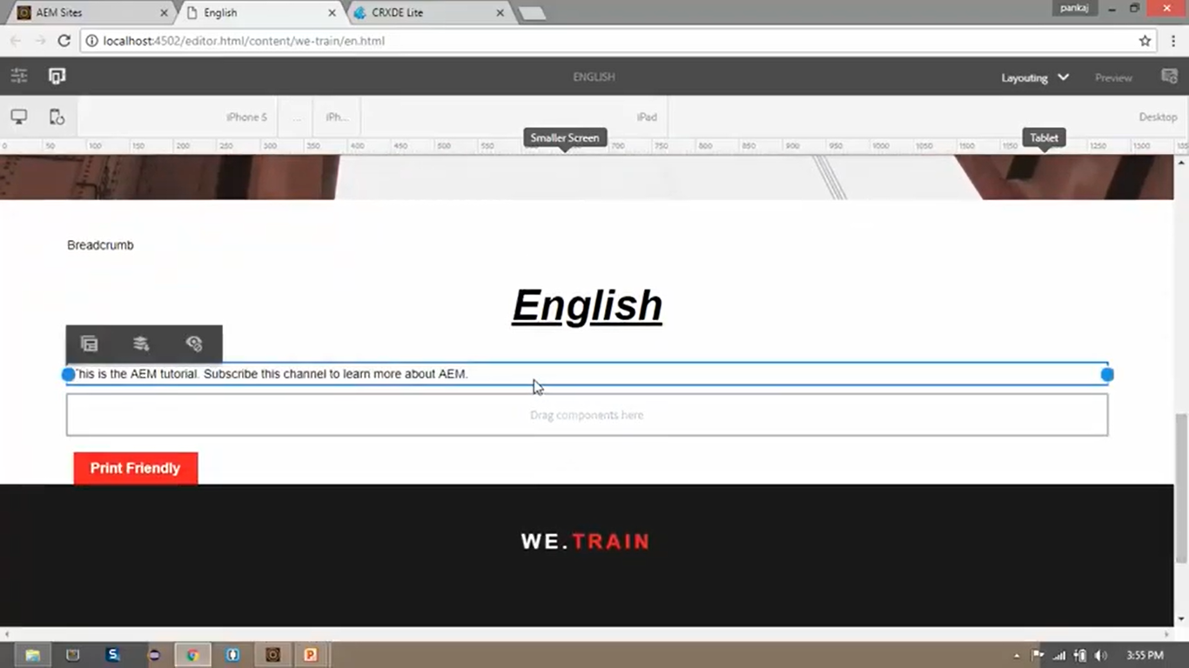

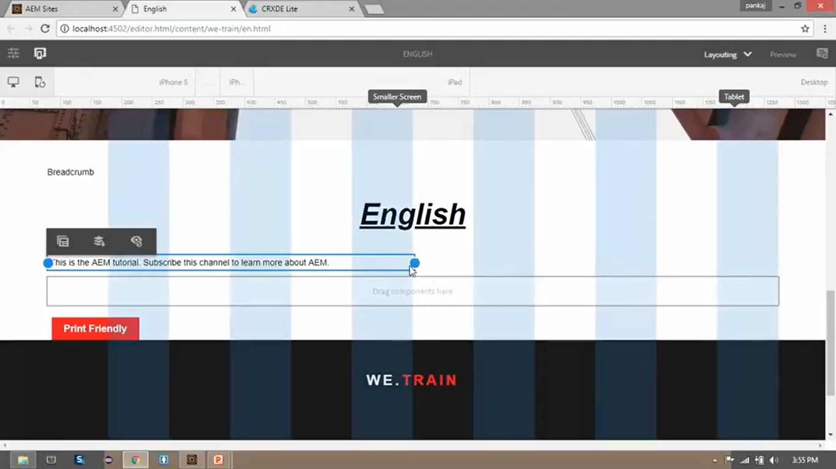

1. After resizing you can check how this will look in different devices for example iPhone5 and iPad (in below screenshots).

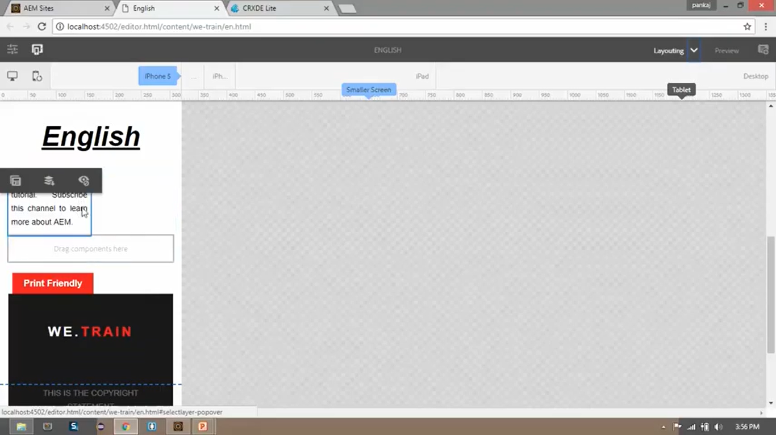

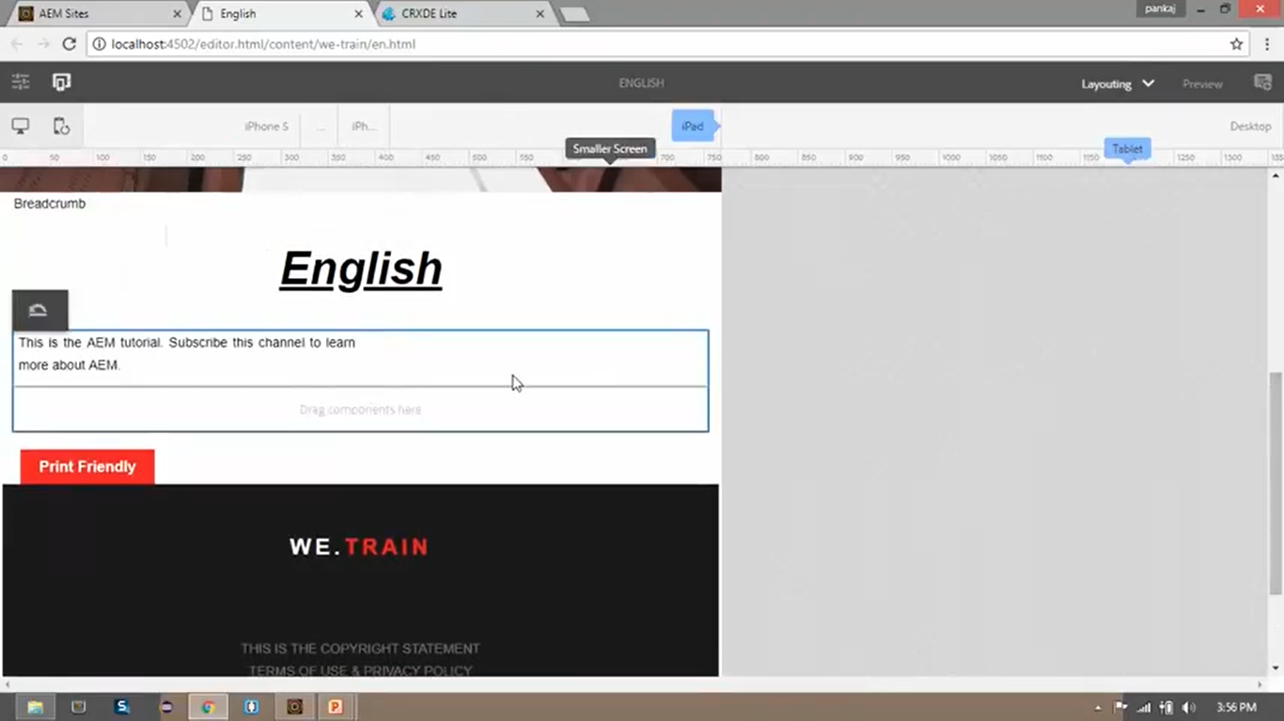

# 56. Breadcrumb component

1. Breadcrumb component is a navigational component which builds a series of links based on the page location in the content hierarchy.
2. It allows the page visitors to navigate through page hierarchy from the current location.
3. Let’s create Breadcrumb component.
4. Open English page <http://localhost:4502/content/we-train/en.html>
5. You can see (below image) that currently the breadcrumbs section simply shows text as “Breadcrumb”
6. We will replace this text with Breadcrumb component.

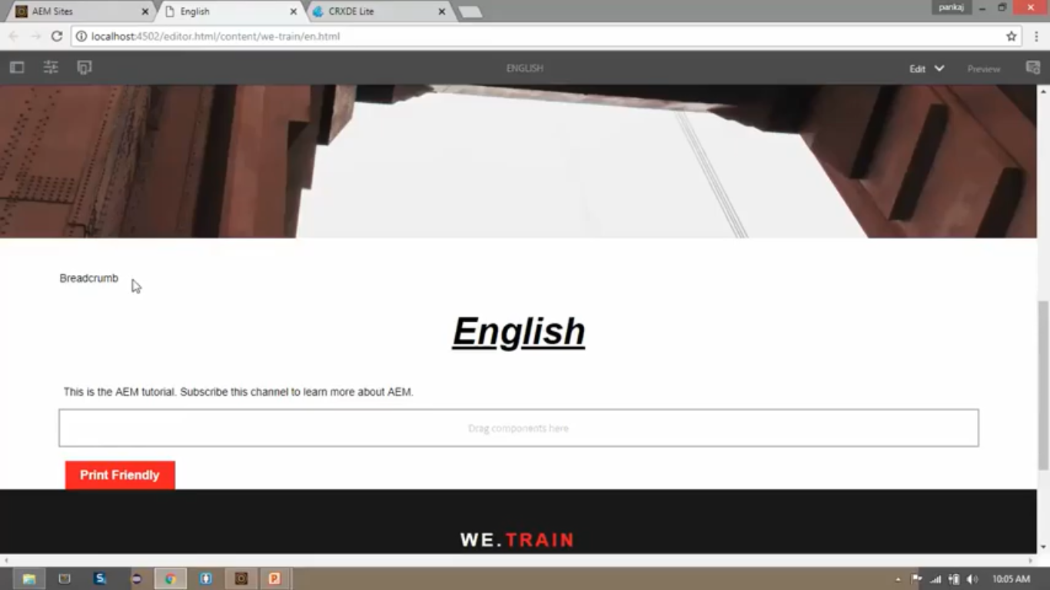

1. AEM provides Breadcrumb component out of the box which is located at below path:

“/libs/foundation/components/breadcrumb”

1. Open file from CRX/DE path “/apps/training/components/structure/contentpage/body.html”
2. See below code at line number 20

**Before Code:**

<div class = “aem-breadcrumb”> Breadcrumb </div>

**After Code:**

<div class = “aem-breadcrumb” data-sly-resoruce = “${‘breadcrumbs’ @ resourceType = ‘foundation/components/breadcrumb’}”> Breadcrumb </div>

1. Remember that we don’t need absolute path “/libs/foundation/components/breadcrumb”
2. We need to provide relative path “/foundation/components/breadcrumb”.
3. Click on “Save All” button.
4. Open We-Train --> English --> Product --> Nokia page

<http://localhost:4502/content/we-train/en/products/nokia.html>

1. Open page in “Preview Mode” by selecting “Preview” option from dropdown at Top-Right of Toolbar.

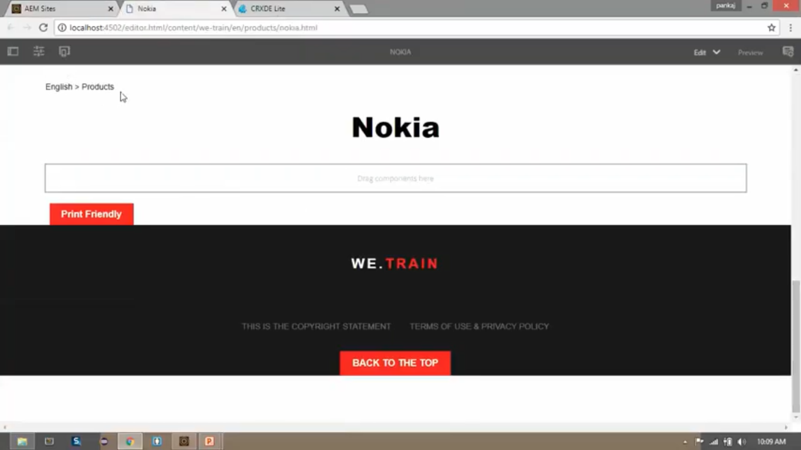

1. This is how breadcrumb helps to identify current location of the page from page hierarchy.
2. You can also click on one of the links from breadcrumbs to navigate to one of the other pages from page hierarchy.

# 57. Modify Navigation button

Go to AEM instance, <http://localhost:4502/projects.html/content/projects>

Click in AEM logo on top left corner. You can see Navigation console (below image) which contains set of Navigation Buttons (Projects, Sites, Assets, etc).

In AEM, UI is based on a set of nodes in JCR repository and these nodes reside in libs folder.

Path of all these nodes is “/libs/cq/core/content/nav”.

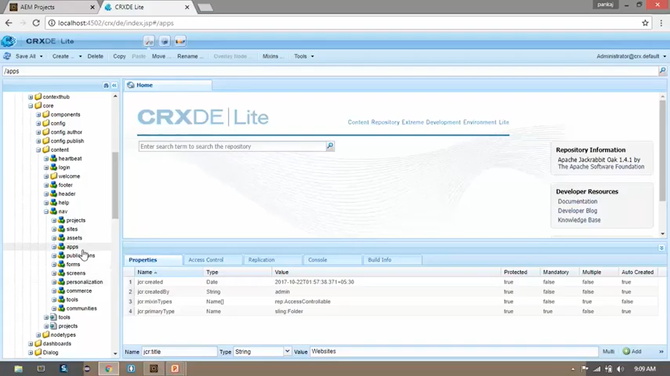

In this section, we will modify sites icon name from “Sites” to “Websites”(below image) .

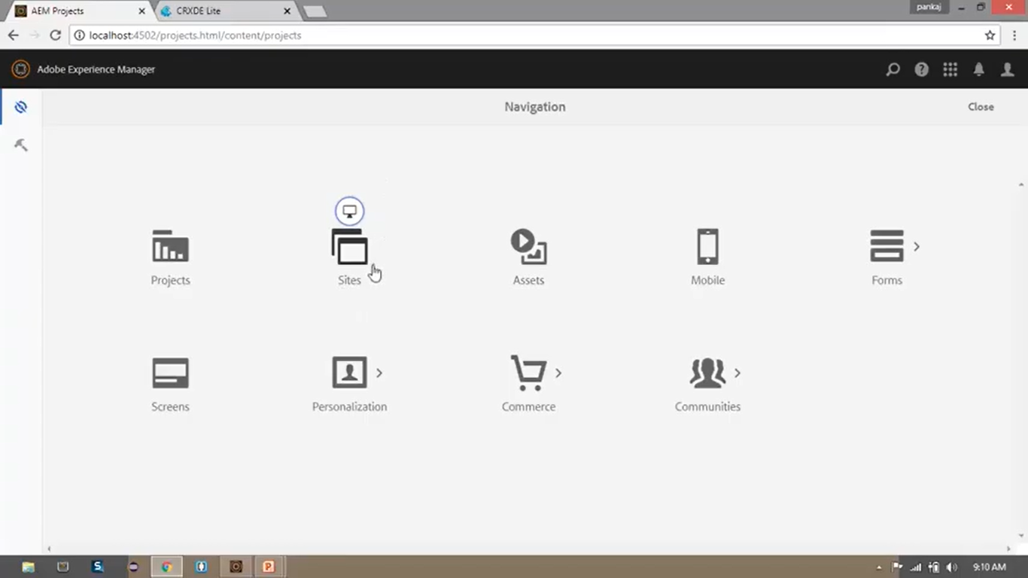

We will use the concept of **Sling Resource Merger** to achieve this functionality.

To do so, right click on CRX/DE node “/libs/cq/core/content/nav/sites” --> Overlay Node .

In Overlay Node dialog box, click on checkbox to check “Match Node Types” field. Click “OK”.

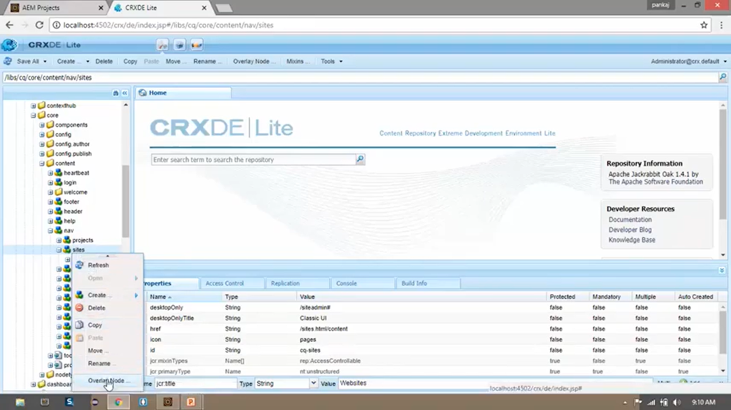 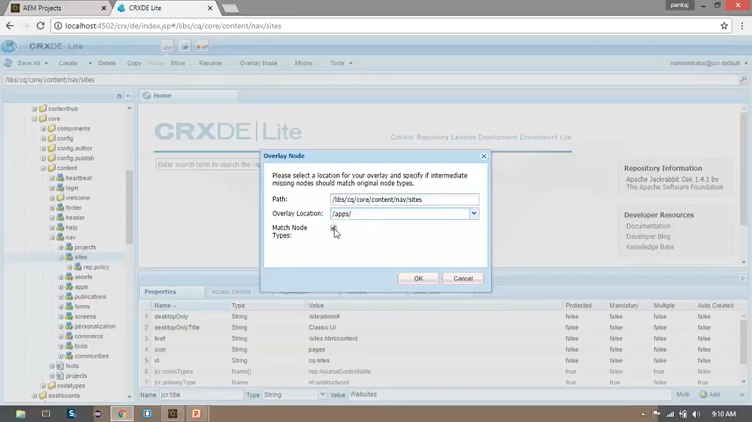

This will create exactly the same structure in root **apps** folder. It will create **cq** folder and its other nested folders inside **apps** folder.

You will not find **cq** folder and its other folders inside **apps** folder unless you right click on **apps** folder and click on “refresh” option.

Once you refresh **apps** folder, you can see exact same folder structure under **apps** folder (below image)

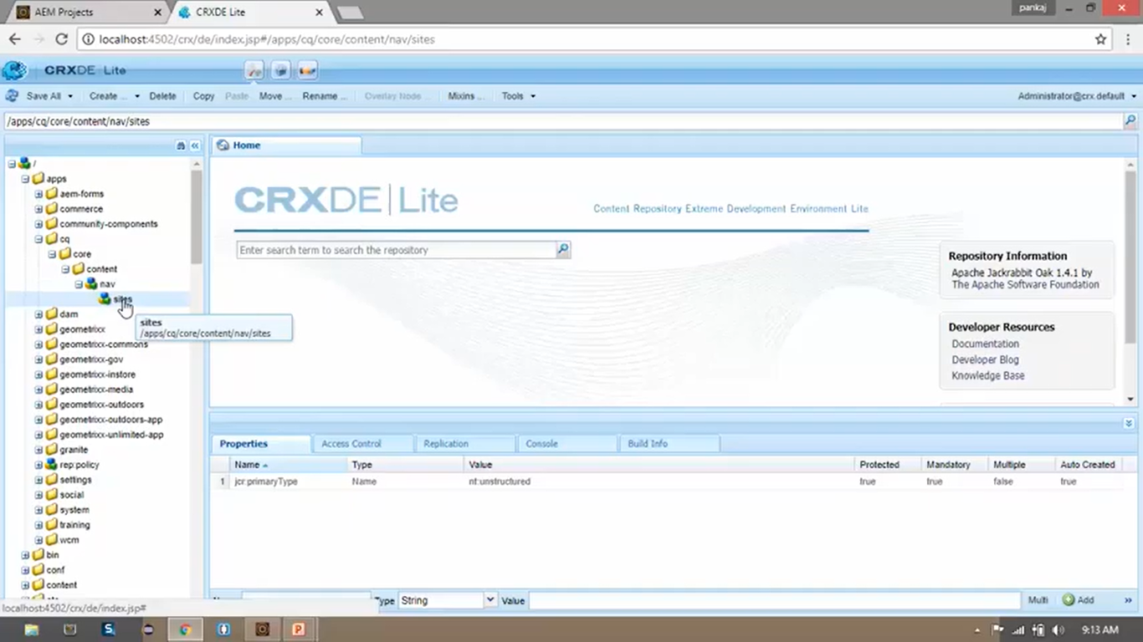

Go back to CRX/DE node “/libs/cq/core/content/nav/sites”. Click on that node. Open Properties Pane to check **Title** of the **Sites** Node to be shown on page. You can find a property field named **jcr:title** with value as **Sites.**

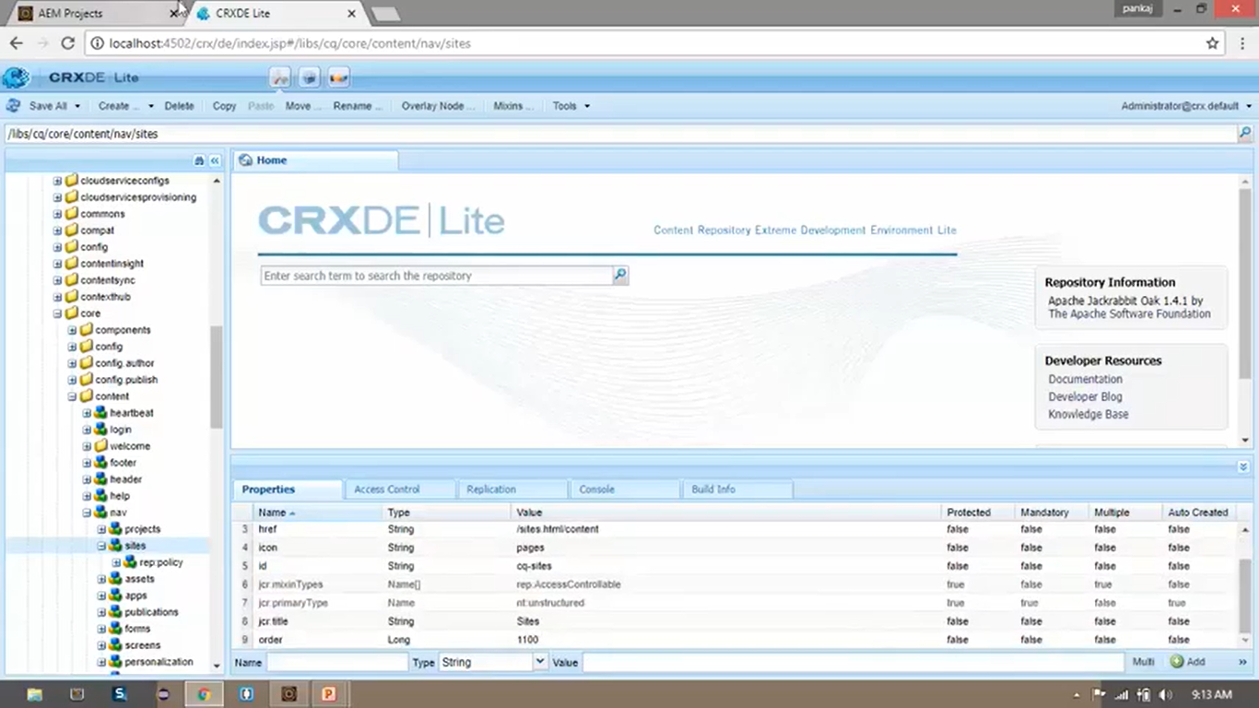

So, if we want to change the **Title** of this **Sites** node, we have to add property to newly created node under path “/**apps**/cq/core/content/nav/sites” from properties pane. Click on “Add” button. Click on “Save All”.

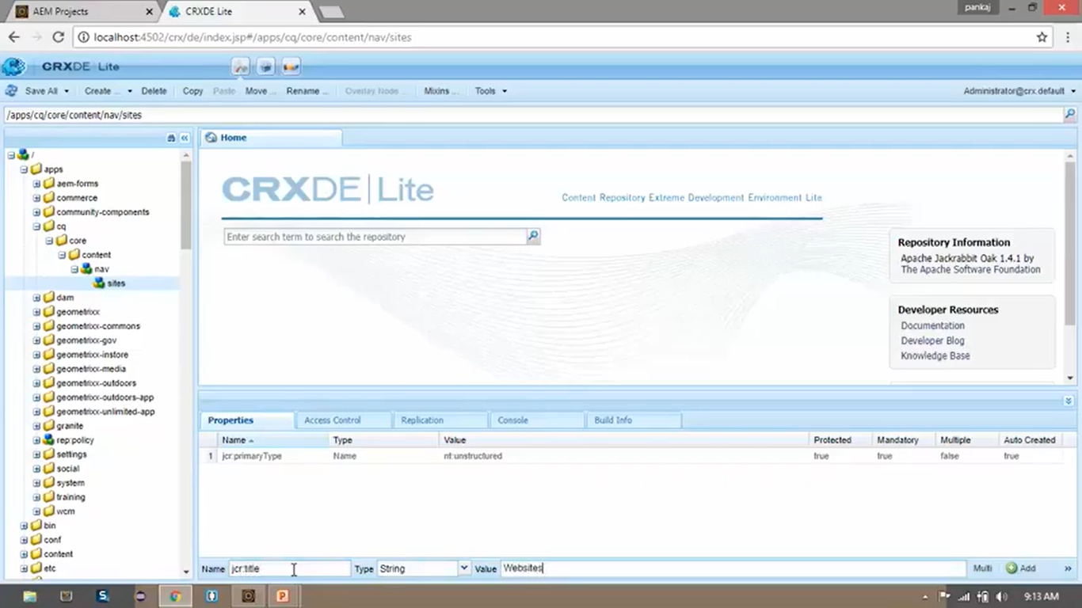

So using this process, we don’t have to overlay or copy the whole structure.

We have only copied required node structure with type as **nt:unstructured.**

And we are changing the only property (**jcr:title**) which we need to change and nothing else.

Now go back to **Navigation Console** and click on browser’s **Refresh** button.

You can see (below image) that the Navigation Menu’s **title** has been changed from **Sites** to **Websites**.

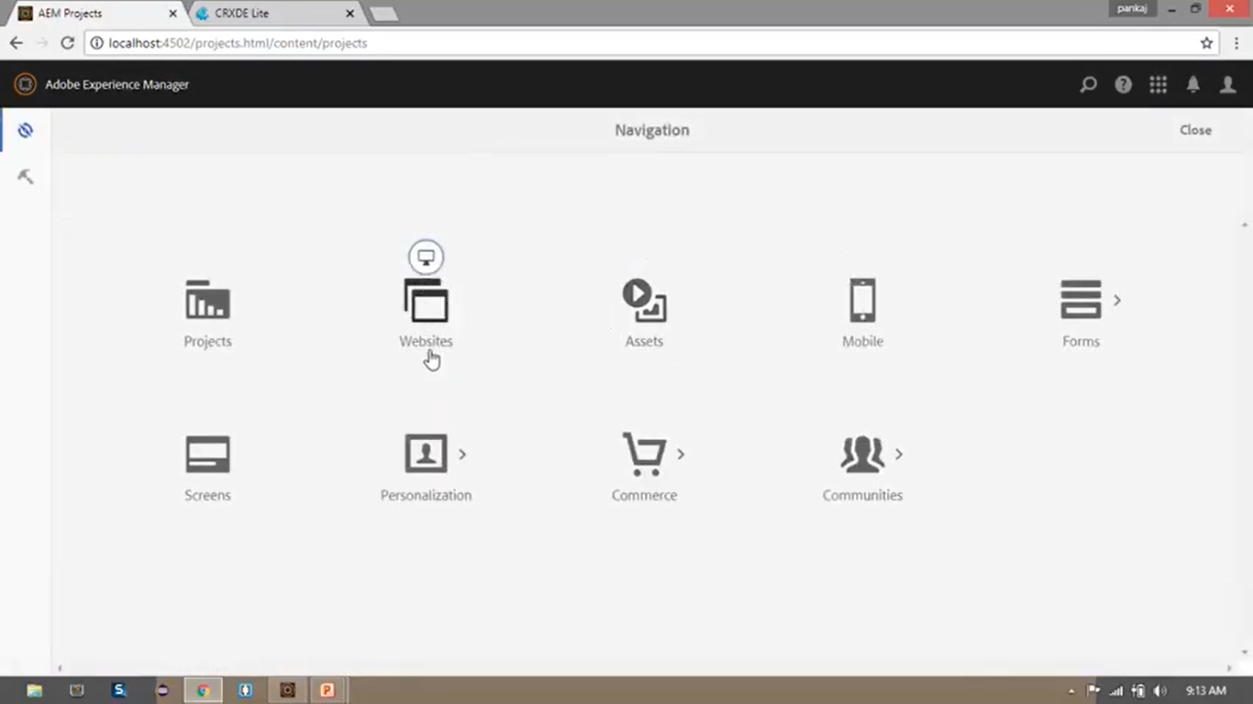

So here we changed the title of the node (Navigation Menu) using the concept **Sling Resource Merger.**

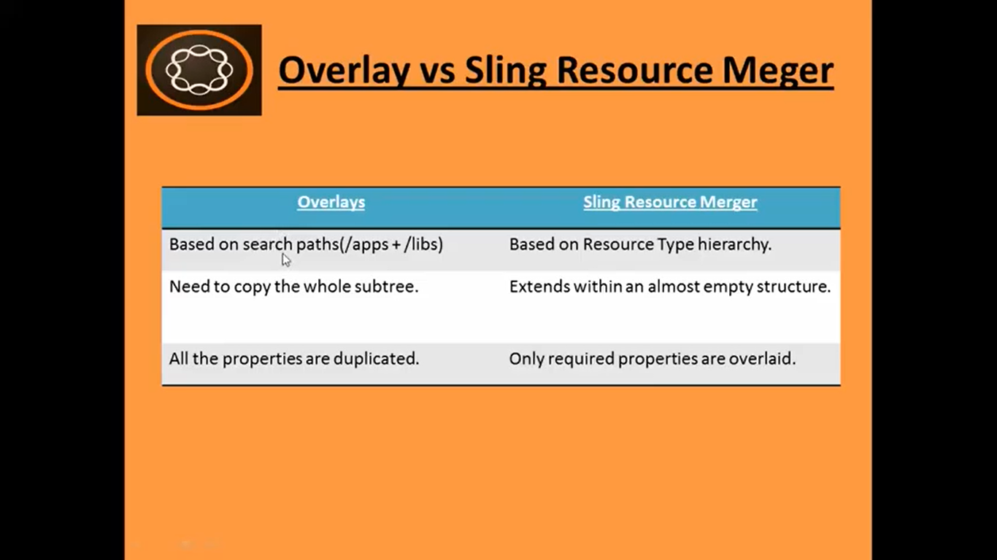

AEM uses **Search Path** to find a resource. It searches a requested resource (from URL) for the **apps** branch first and if it doesn’t find the path under this **apps** branch, it will search under **libs** branch.

So your newly copied components under **apps** get higher priority over components present **libs** branch.

For point number 3, in our example we just **overlaid** only required property **jcr:title.**

So, in short, we using **Sling Resource Merger,** we reduce the structure which is duplicated from **libs** branch

We should not modify **libs** branch, and hence we should use one of the above 2 methods.

If only few properties are to be changed, then we should **opt for** --> **Sling Resource Merger** technique.

# 58. Create Custom Error Handler

Open English page <http://localhost:4502/content/we-train/en.html> It will open page.

But if enter incorrect URL with page **vn.html**, then it will give below error.

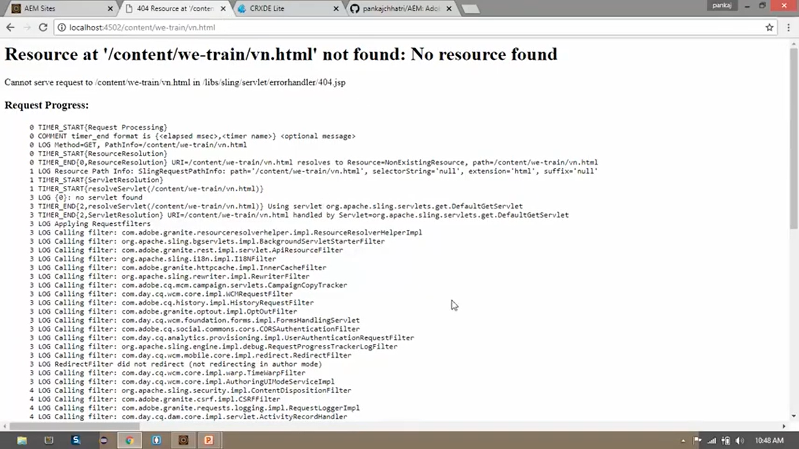

We will create our custom 404 Error Handler, which will show a error from our website.

Go to CRX/DE. Right click on node “/libs/sling/servlet/errorhandler” --> select “Overlay Node” option.

In Overlay Node dialog box, click on checkbox to check “Match Node Types” field. Click “OK”.

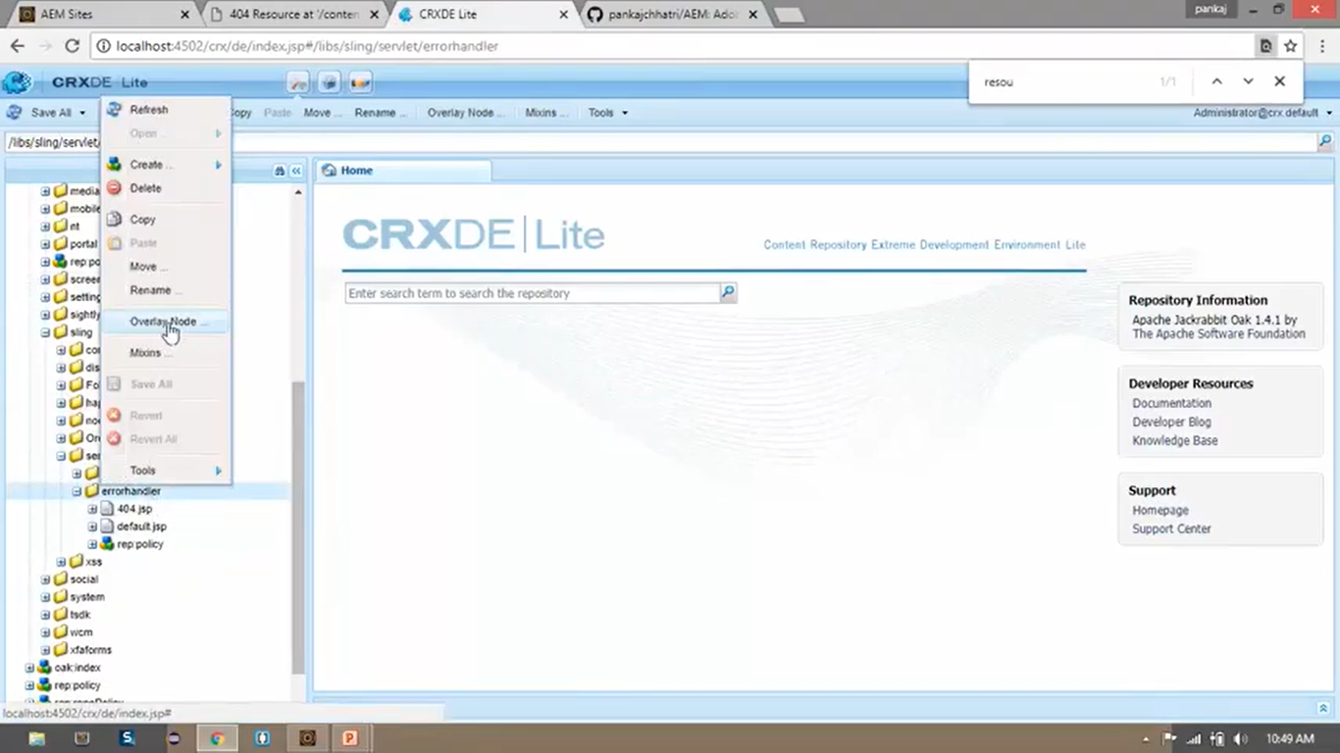 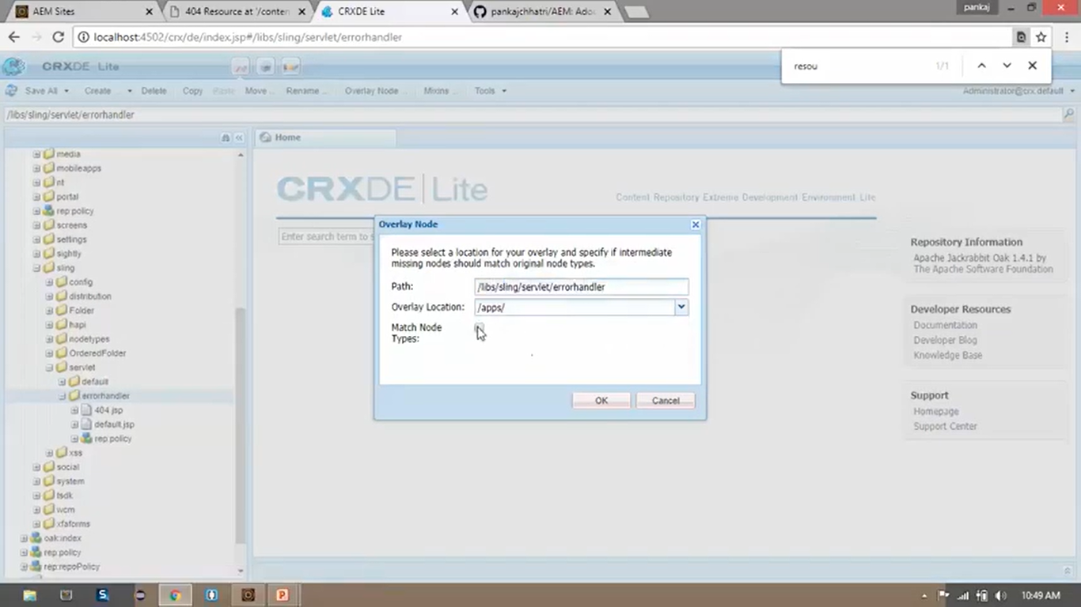

This will create exactly the same folder structure in root **apps** folder. It will create **cq** folder and its other nested folders inside **apps** folder after you refresh the folder.

To check whether same folder structure has been created, Go to CRX /DE path “/apps/sling/servlet/errorhandler”.

We will create our own folder structure within this errorhandler folder.

To do so, Right click on this node “/apps/sling/servlet/errorhandler” --> Create --> Create File (2 times)

File names will be **404.html** and **ResponseStatus.java**

Go to <https://github.com/pankajchhatri/AEM>

Go to [Developer course](https://github.com/pankajchhatri/AEM/tree/master/Developer%20course) --> [Chapter 13 Advanced Sling Functionality](https://github.com/pankajchhatri/AEM/tree/master/Developer%20course/Chapter%2013%20Advanced%20Sling%20Functionality) --> [Lab - Custom Error Handlers](https://github.com/pankajchhatri/AEM/tree/master/Developer%20course/Chapter%2013%20Advanced%20Sling%20Functionality/Lab%20-%20Custom%20Error%20Handlers) --> Task 1 - Create a custom 404 [error](https://github.com/pankajchhatri/AEM/tree/master/Developer%20course/Chapter%2013%20Advanced%20Sling%20Functionality/Lab%20-%20Custom%20Error%20Handlers/Task%201%20-%20Create%20a%20custom%20404%20error%20handler) handler

Copy code of **404.html** and **ResponseStatus.java** into respective files in our CRX/DE.

Click on “Save All” button.

|  |  |
| --- | --- |
| **404.html** | <html data-sly-use.responseStatus ="apps.sling.servlet.errorhandler.ResponseStatus">  <head>  <title>File not found</title>  </head>  <body>  <p>A custom errorhandler for 404 responses</p>  </body>  </html> |

|  |  |
| --- | --- |
| **ResponseStatus.java** | package apps.sling.servlet.errorhandler;  import com.adobe.cq.sightly.WCMUsePojo;  public class ResponseStatus extends WCMUsePojo {    @Override  public void activate() throws Exception {  getResponse().setStatus(404);  }  } |

Open <http://localhost:4502/content/we-train/vn.html> to see error message from our custom error page.

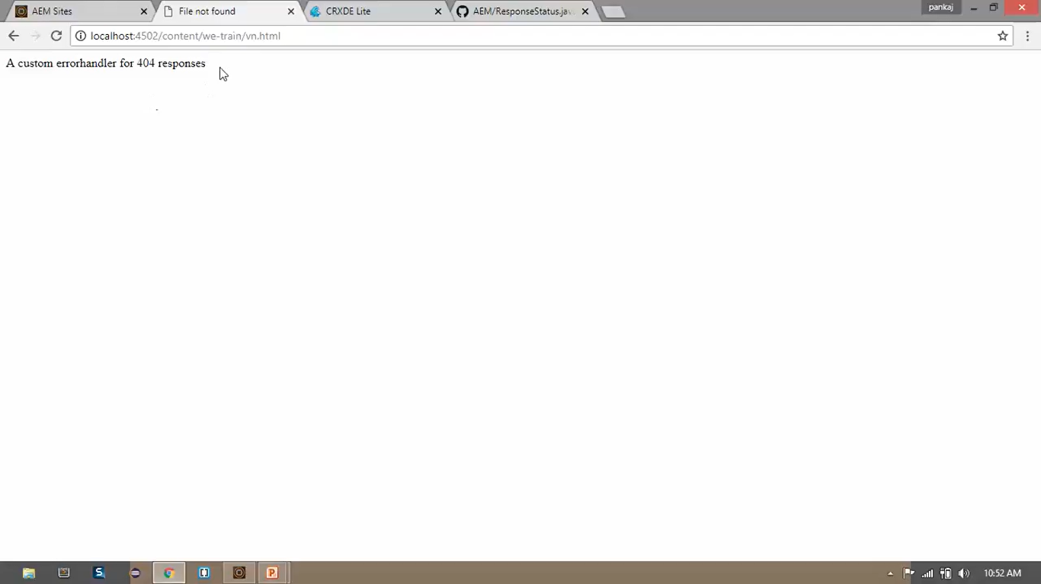

# 59. Build an AEM 6.4 project using Maven Archetype 13

1. We will be using MAVEN which is a build and deployment tool which uses conf file.
2. This conf file contains all the configurations, dependencies and plugins related information about the project.
3. We will be using minimum version of 3.3.9 of Maven if we’re using Maven Archetype 13.
4. Archetype is a maven project templating toolkit. It provides templating solution for the project and it helps to create sample project structure which we can extend based on your business requirements.
5. If you have AEM version 6.2 you can use Archetype version 10 or 11
6. If you have AEM version 6.3 you can use Archetype version 12
7. We will be using Archetype version 13 to build our project in AEM 6.4.
8. **GroupId** is a Unique Identifier used to uniquely identify your project in Maven Repository.
9. **ArtifactId** is your Project Name

Before using Maven Archetype command, you should have Java 1.8 version installed and Maven minimum 3.3.9 installed.

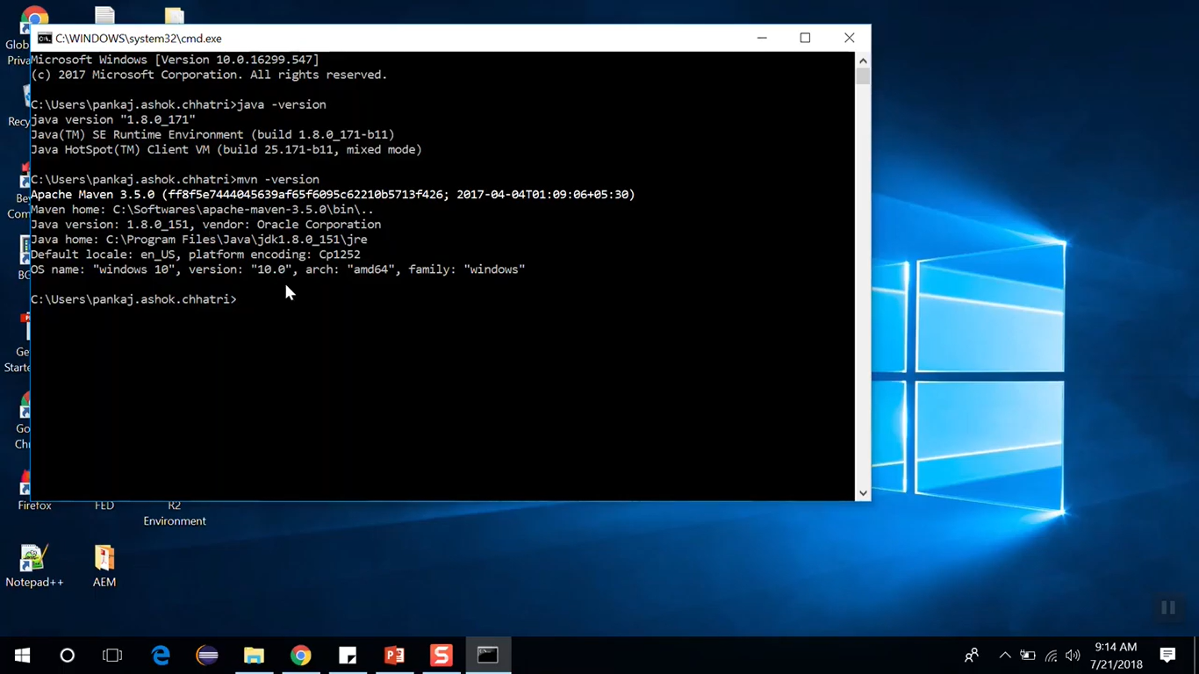

Go to Maven folder --> apache-maven-3.5.0 --> conf --> settings.xml

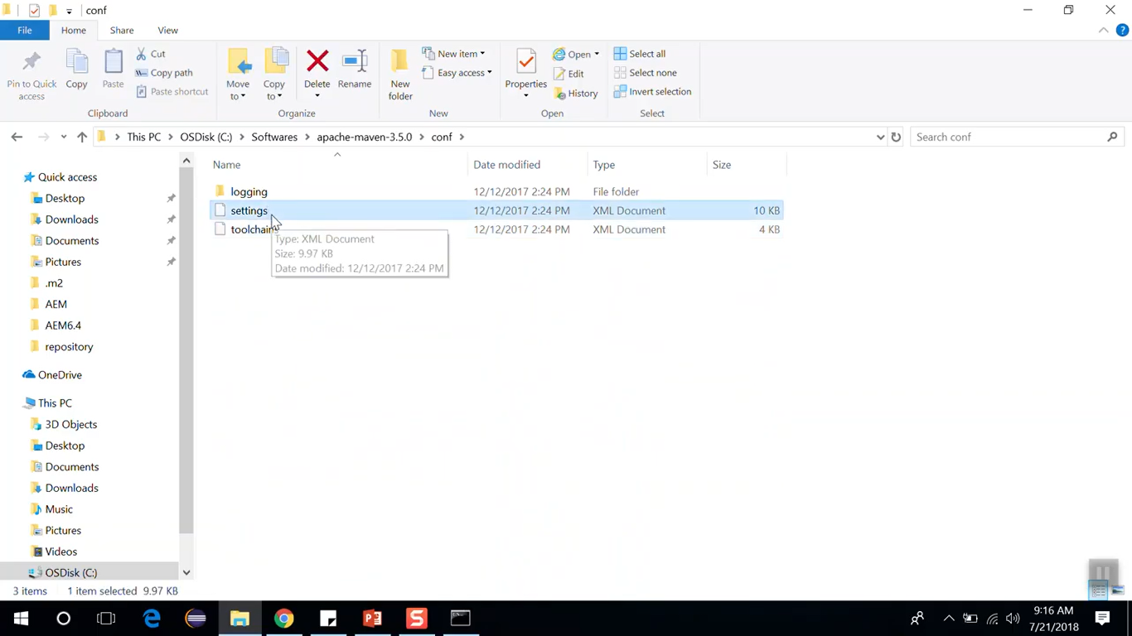

Copy Settings.xml and paste into your profile, that is, “C:/Users/Deepak/.m2” folder.

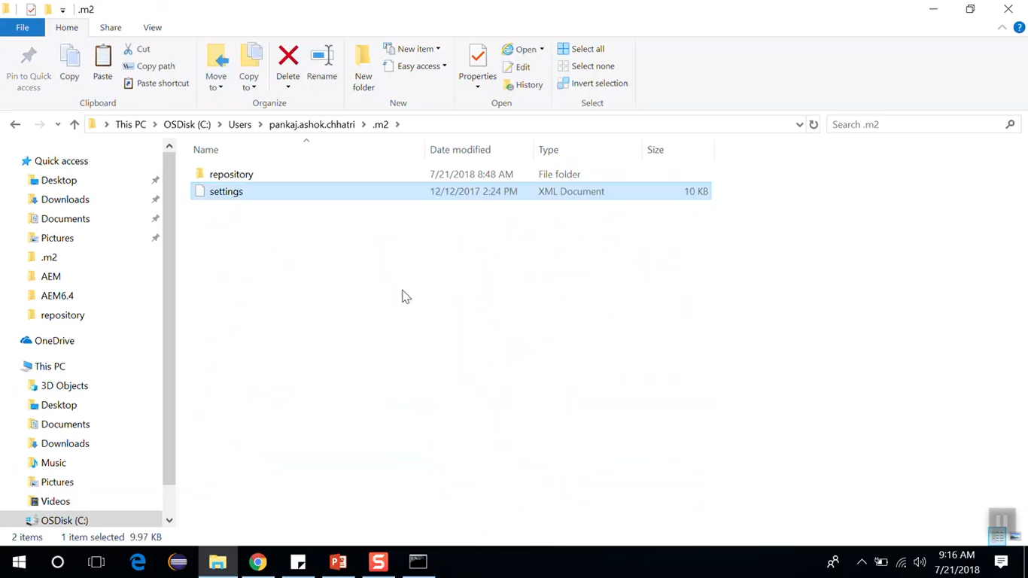

This is the file which by default comes with Maven. Edit this Settings.xml file.

Go to <https://github.com/pankajchhatri/AEM>

Go to [Developer course](https://github.com/pankajchhatri/AEM/tree/master/Developer%20course) --> [Settings.xml](https://github.com/pankajchhatri/AEM/blob/master/Developer%20course/settings.xml/)

Copy the contents of this file and paste it to our file **C:/Users/Deepak/.m2/Settings.xml**.

Save the File.

Now go to the folder where you want to create the project. Let’s consider **C:/demo** folder.

Open command prompt at **C:/demo** folder.

Go to <https://github.com/pankajchhatri/AEM>

Go to [Developer course](https://github.com/pankajchhatri/AEM/tree/master/Developer%20course) --> [AEM-Archetype](https://github.com/pankajchhatri/AEM/blob/master/Developer%20course/AEM-Archetype)

Copy the file content (Maven command) and paste it in command prompt which just opened.

It will prompt for some of the field values. Enter below values:

|  |  |  |
| --- | --- | --- |
| Field Name | Field Value | Description |
| groupId | com.aem.demo | Unique Id of the project |
| artifactiId | demotraining | Name of the project |
| version | 1.0-SANPSHOT | Keep default |
| package | com.aem.demo | Keep same as groupId |
| appsFolderName | demotraining | folder where template and component resides. |
| artifactName | demotraining |  |
| componentGroupName | demotraining | which will appear for your component in sitedrill of sitekick |
| confFolderName | demotraining | folder where editor template resides |
| contentFlderName | demotraining | folder where website pages resides |
| cssId | demotraining |  |
| packageGroup | demotraining |  |
| siteName | DemoSite | This site name will appear in site admin. |

Click on **Enter** **↵**. You can review your names and parameters and type **Y** to continue.

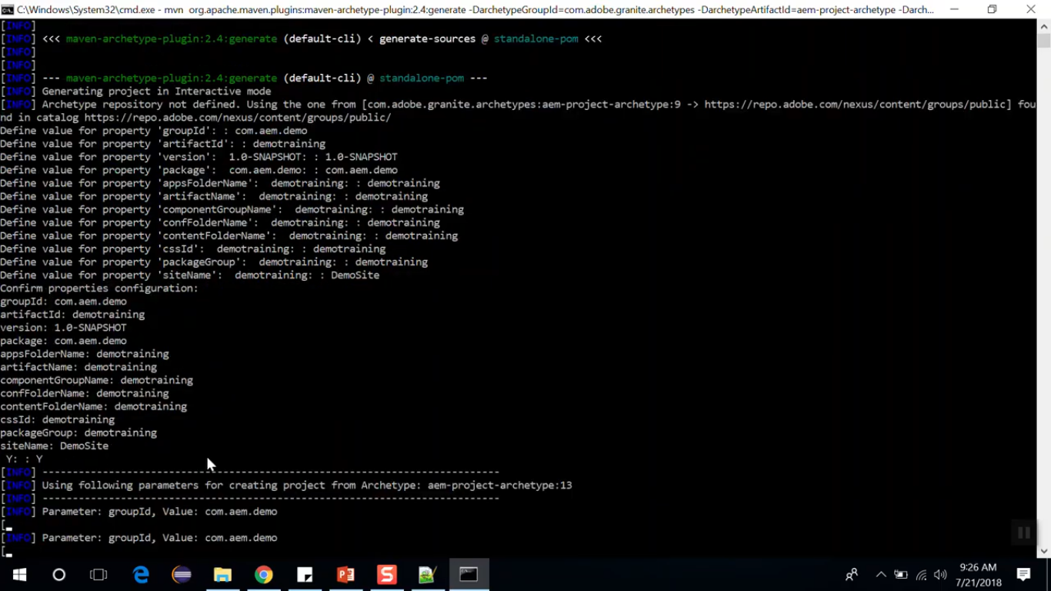

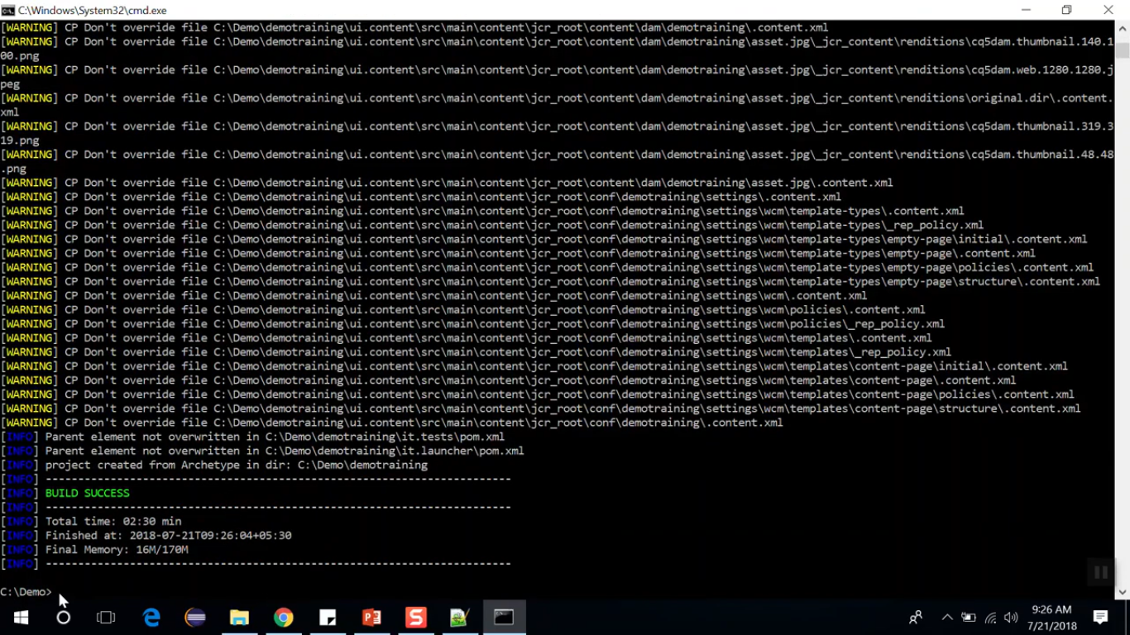

**BUILD SUCCESS** means that your project has been successfully created.

If you go to your folder **C:/demo**, you can see that the folder **C:/demo/demotraining** has been created.

This is your project folder.

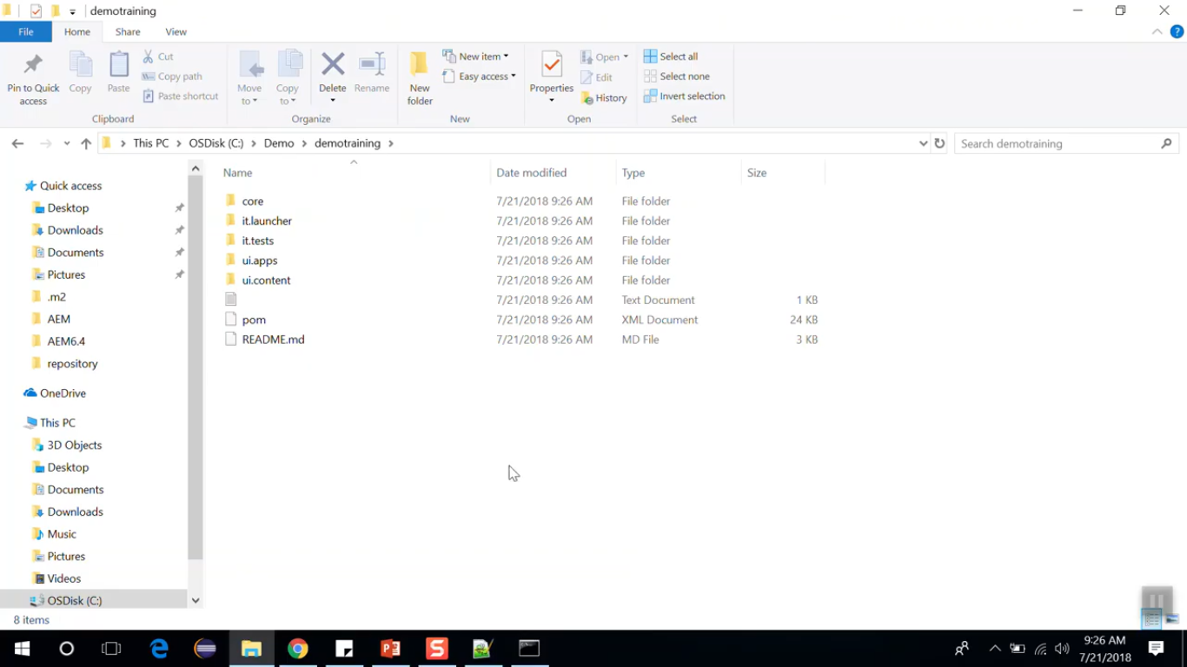

# 60. Build and Deploy project in AEM 6.4

Start you AEM instance first. Lets it is installed at “C:/AEM 6.4” folder.

Double click to open **cq5-author-p4504.jar file** to open AEM instance

Till it gets start, you can go to your newly created project’s folder **C:/demo/demotraining.**

Open **POM.xml** (Project Object Model) file present at projects root folder **C:/demo/demotraining.**

Open **AEM instance launcher**. You can see on the **AEM launcher dialog** that it is showing that **local AEM instance** is open on **port number** 4504.

Hence, we need to **change** the **port number** mentioned in the **POM.xml** file at line number 35 (below image) from **4502** to **4504**. Now, **Save** the file and **close** it.

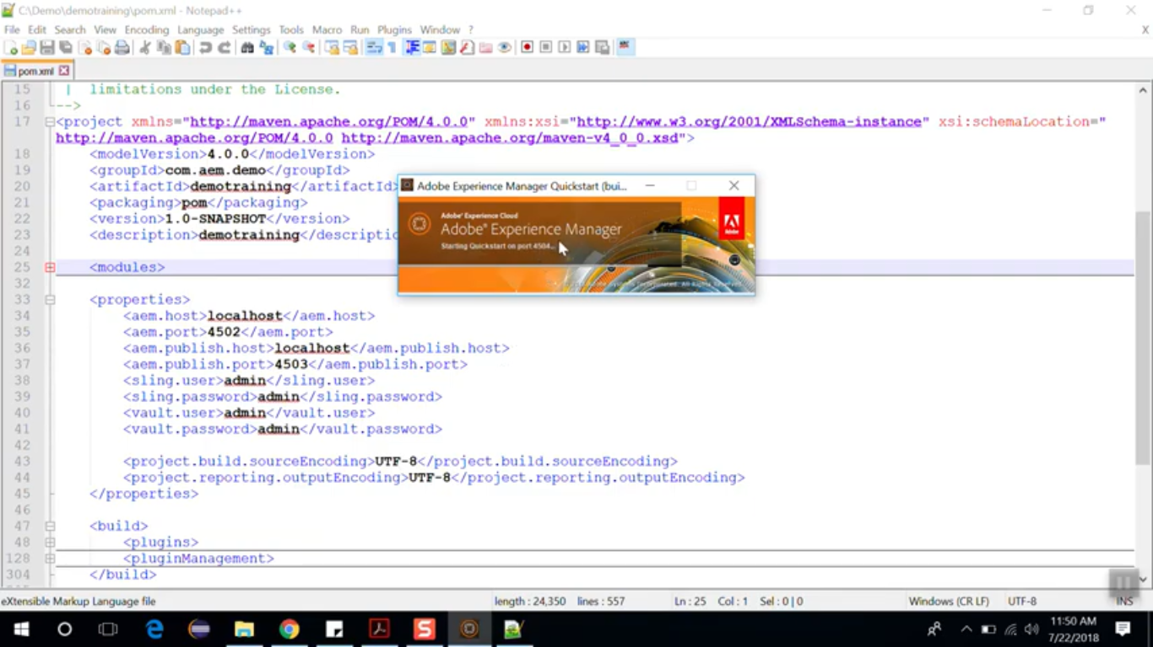

Once **AEM instance** has been **completely started**, it will **open** it on browser.

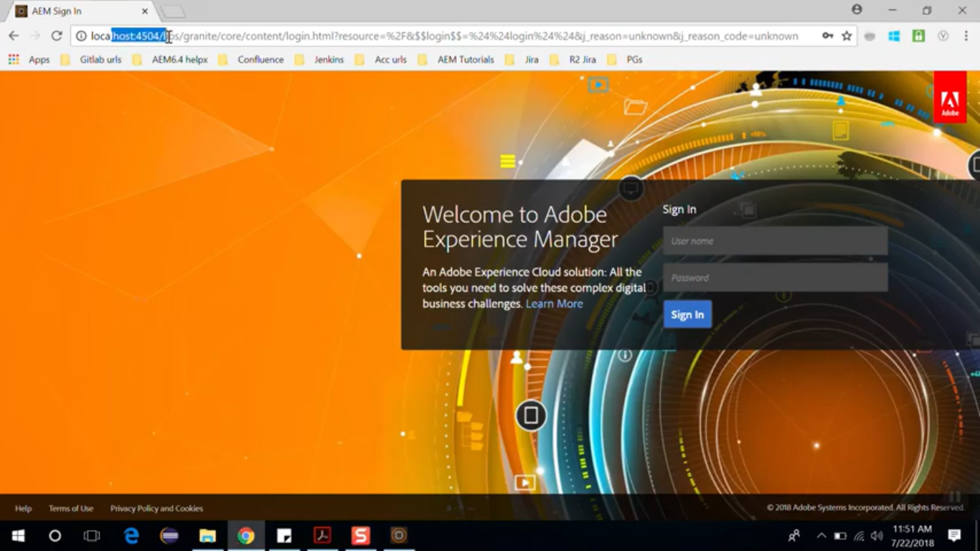

Now, let’s see how to build the project.

Go to project folder **C:/demo/demotraining**. Open command prompt from of this folder path.

Run below Maven command mvn clean install -PautoInstallPackage

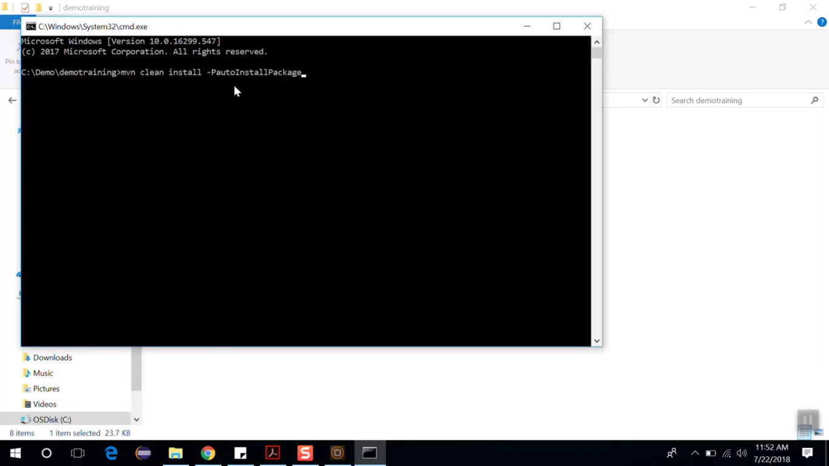

Here this auto install package is the maven profile which is used to deploy the AEM project.

It will take some time to build and deploy the project.

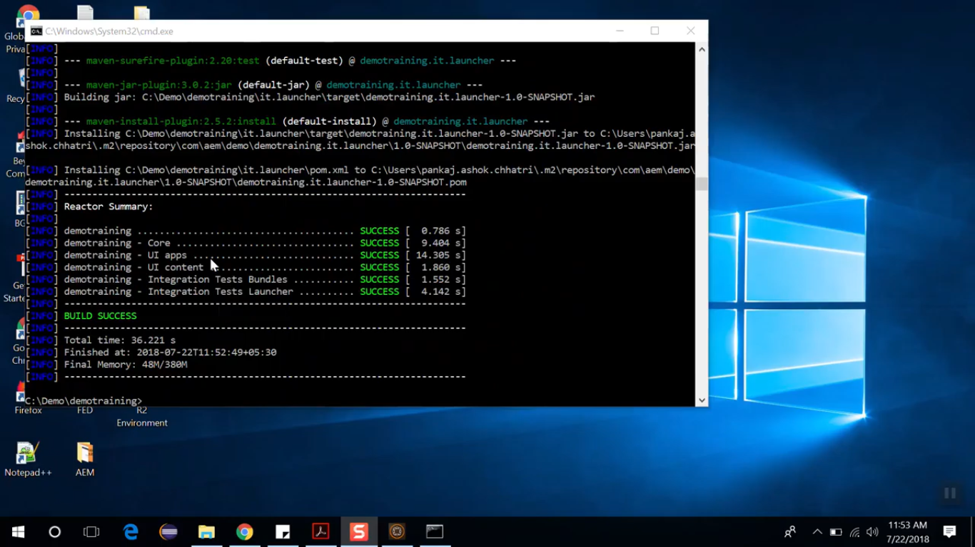

Once you see the build is succeeded, go to **package manager.** [http://localhost:**4504**/crx/packmgr](http://localhost:4504/crx/packmgr) to see which **5** packages got installed. 3 are core component packages, while 2 are project related.

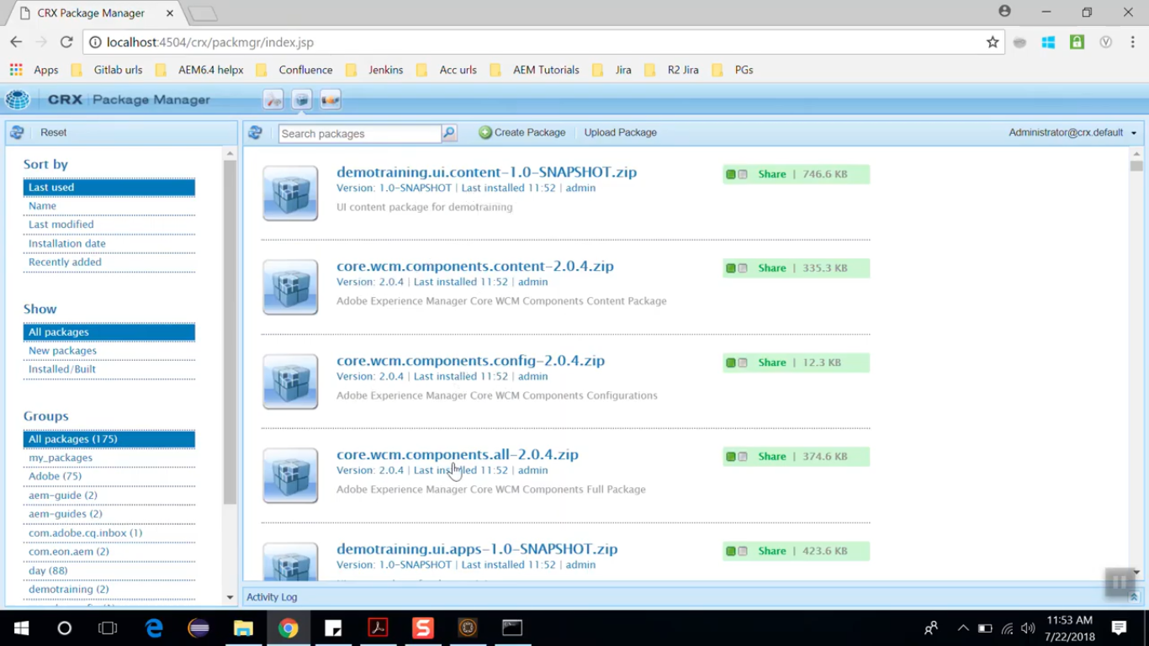

Go to **Site Console** <http://localhost:4504/sites.html/content>. You will see that it has created a new site named DemoSite. If you click on it you will see that it has 2 pages named English and French. Click on **English page** and then on **Edit icon** to openthe page. It will open <http://localhost:4504/editor.html/content/demotraining/en.html>

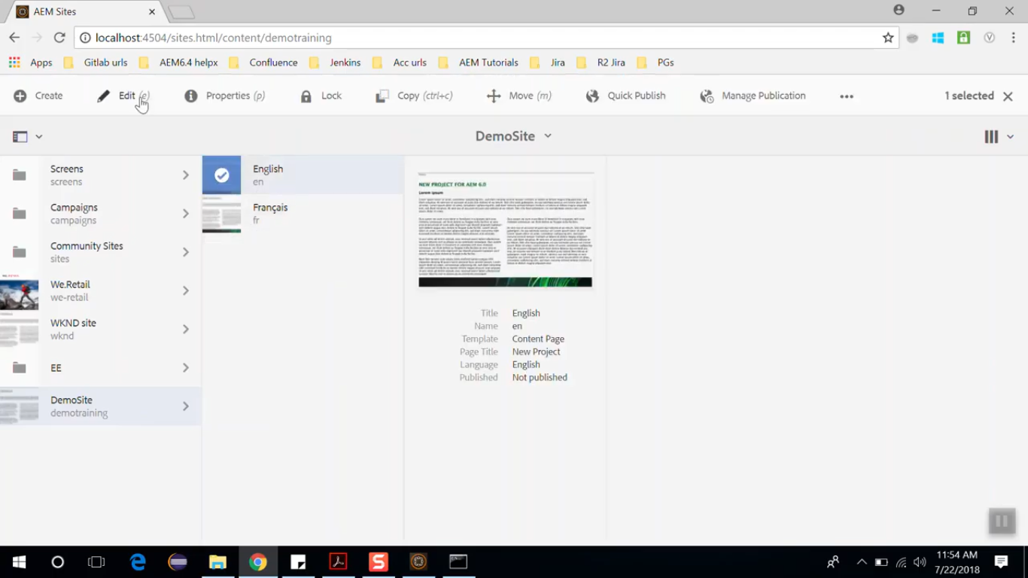

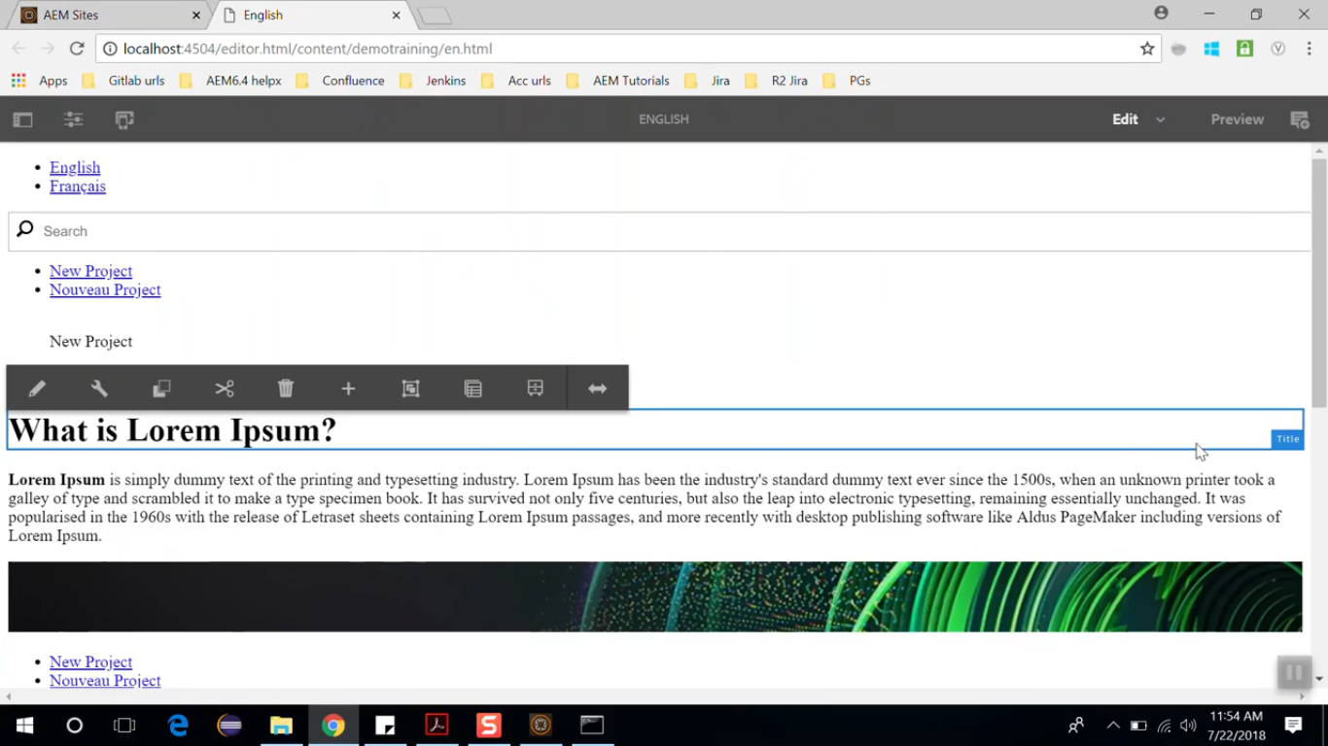

You can see that this page has lots of components, such as, Title component, Search component, Text component.

You can open page in **Developer mode** to see page has which all components.

To open page in **Developer mode**, click on **dropdown** present on **Toolbar** at top right corner and then select **Developer** option.

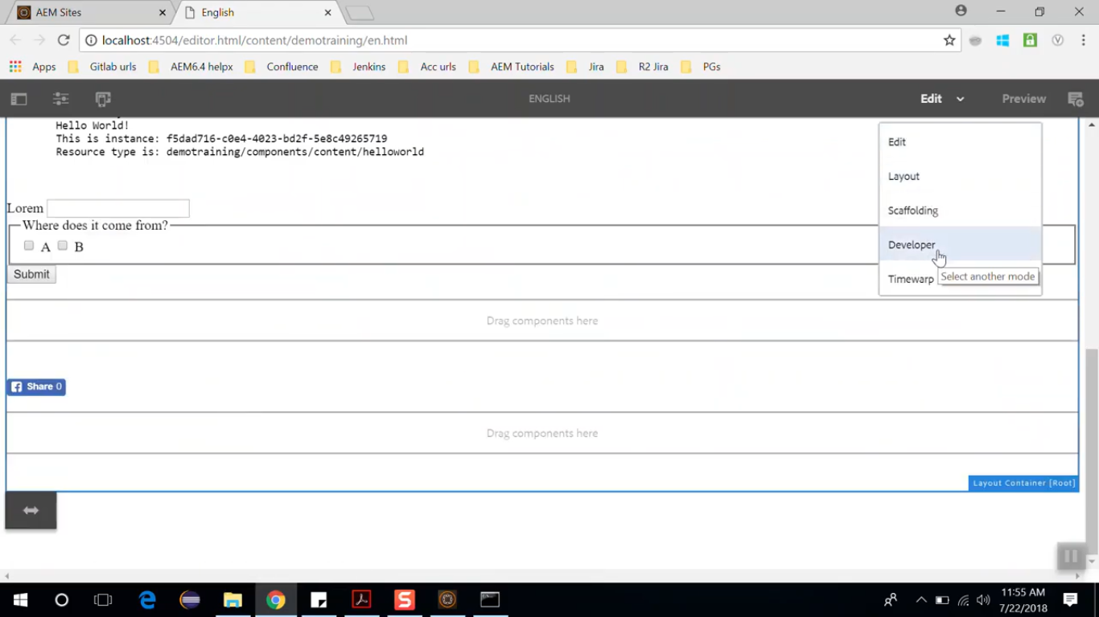

You can click on **Social Media** component on page, you can scroll down on **Components** pane on left side.

You can click on **Show Details** icon (cursor pointer), to see which all scripts are running for this component and which path is it using.

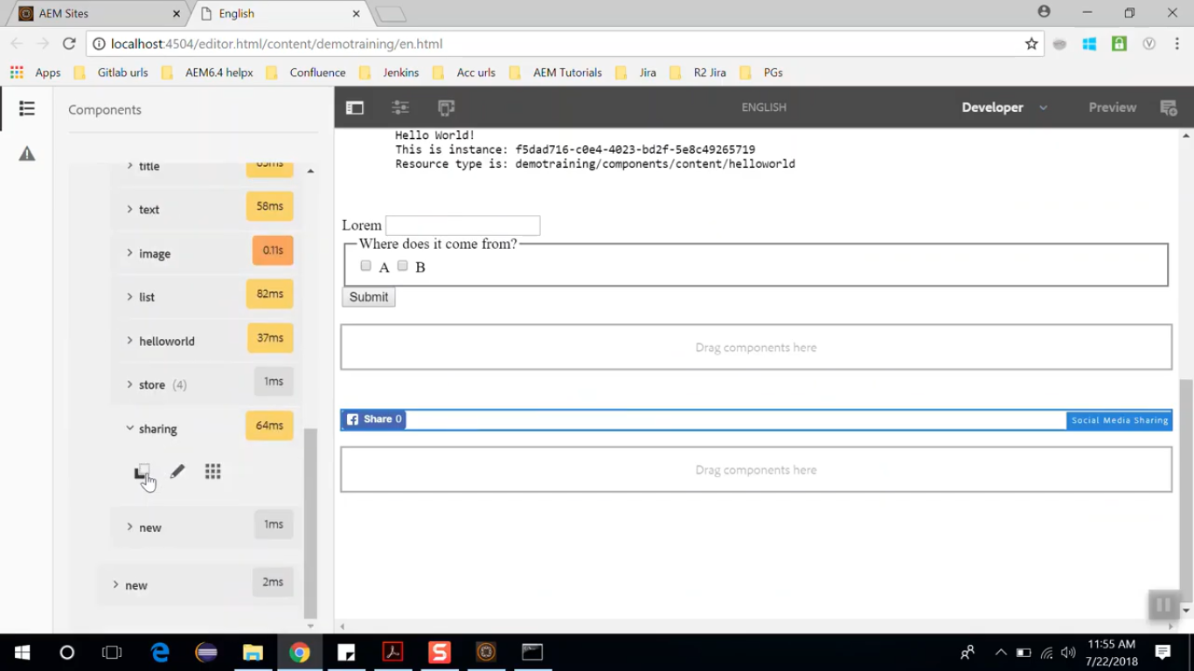

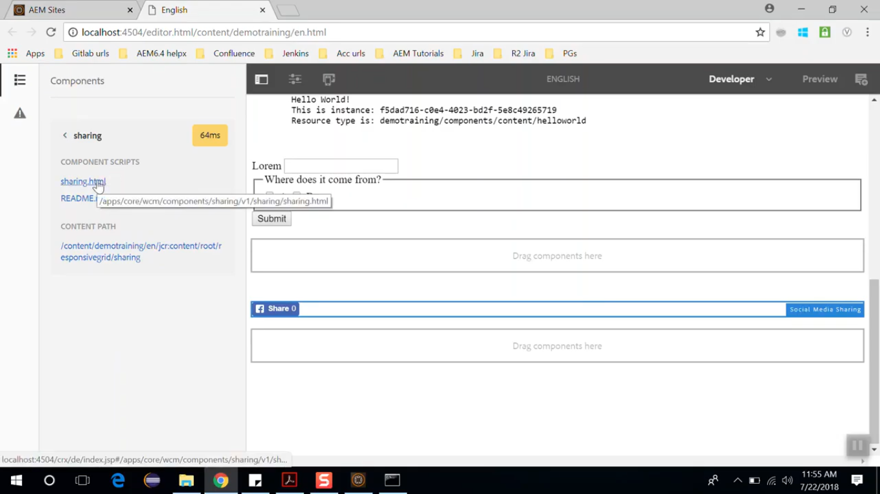

You can also click on **Title** component and then click on Edit icon (cursor pointer) and it will take you to the Title component of the CRX/DE.

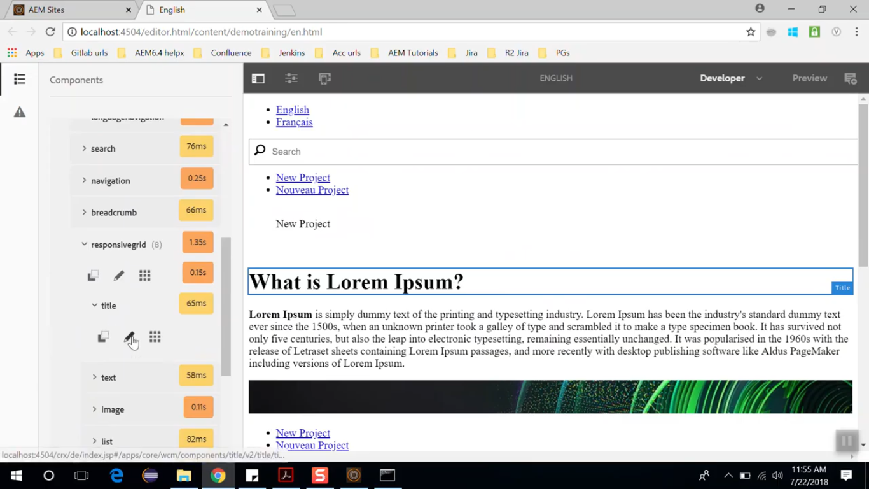

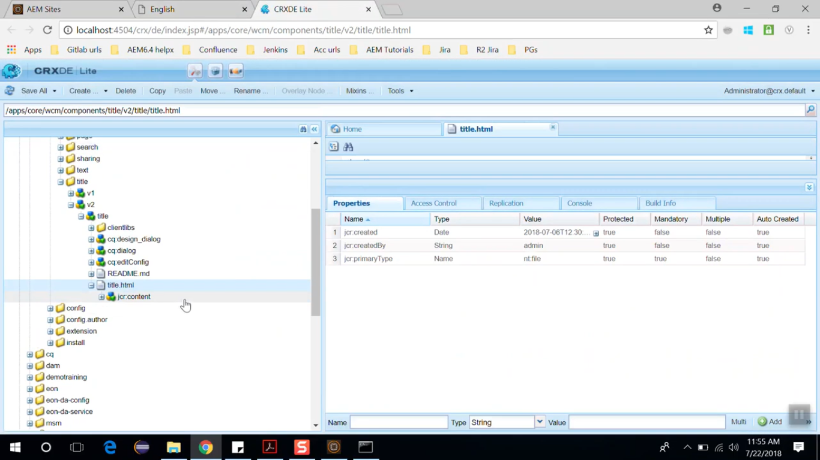

This way you can go to different components, edit & configure them and locate them out.

# 61. AEM project structure and importing project in Eclipse IDE

Below is the Project structure of our **Demo Training** AEM project.

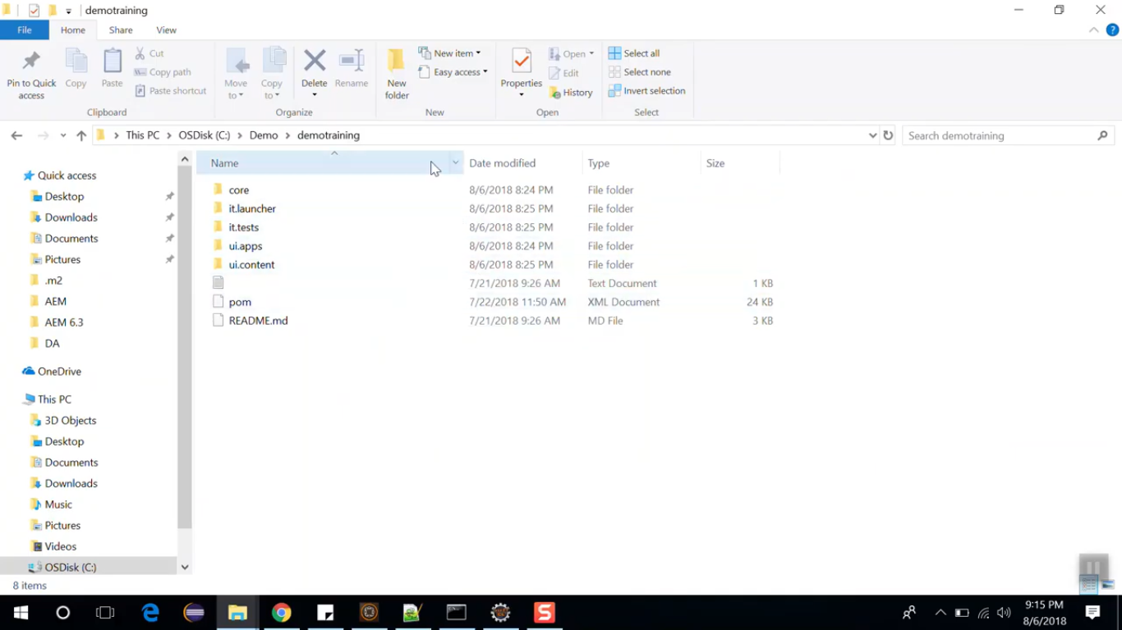

|  |  |
| --- | --- |
| **Folder Name** | **Description** |
| core | It includes all the java code and deploy to AEM as OSGI bundle. |
| it.launcher | contains code that deploys it.tests bundle to the servers and triggers remote Junit execution. |
| it.tests | J Unit tests which are executed server side |
| ui.apps | apps part of the project |
| ui.content | content and configurations of the project |
| POM.xml | project configuration file. |

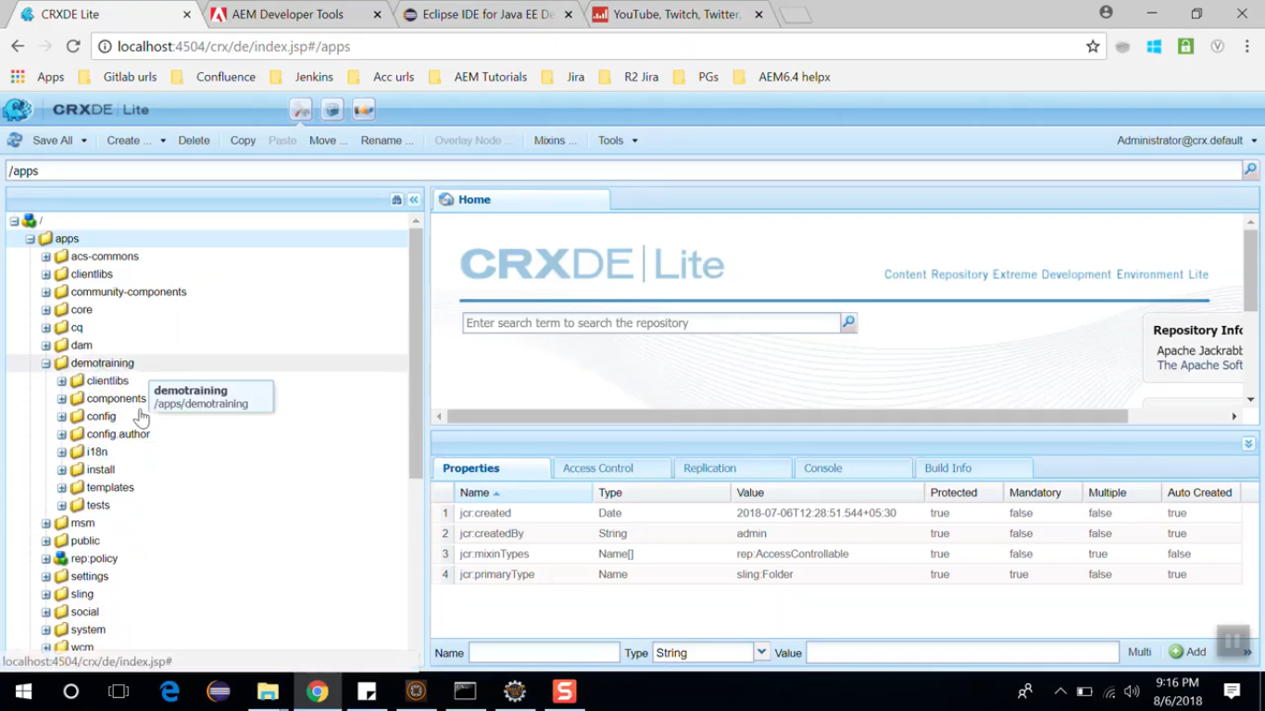 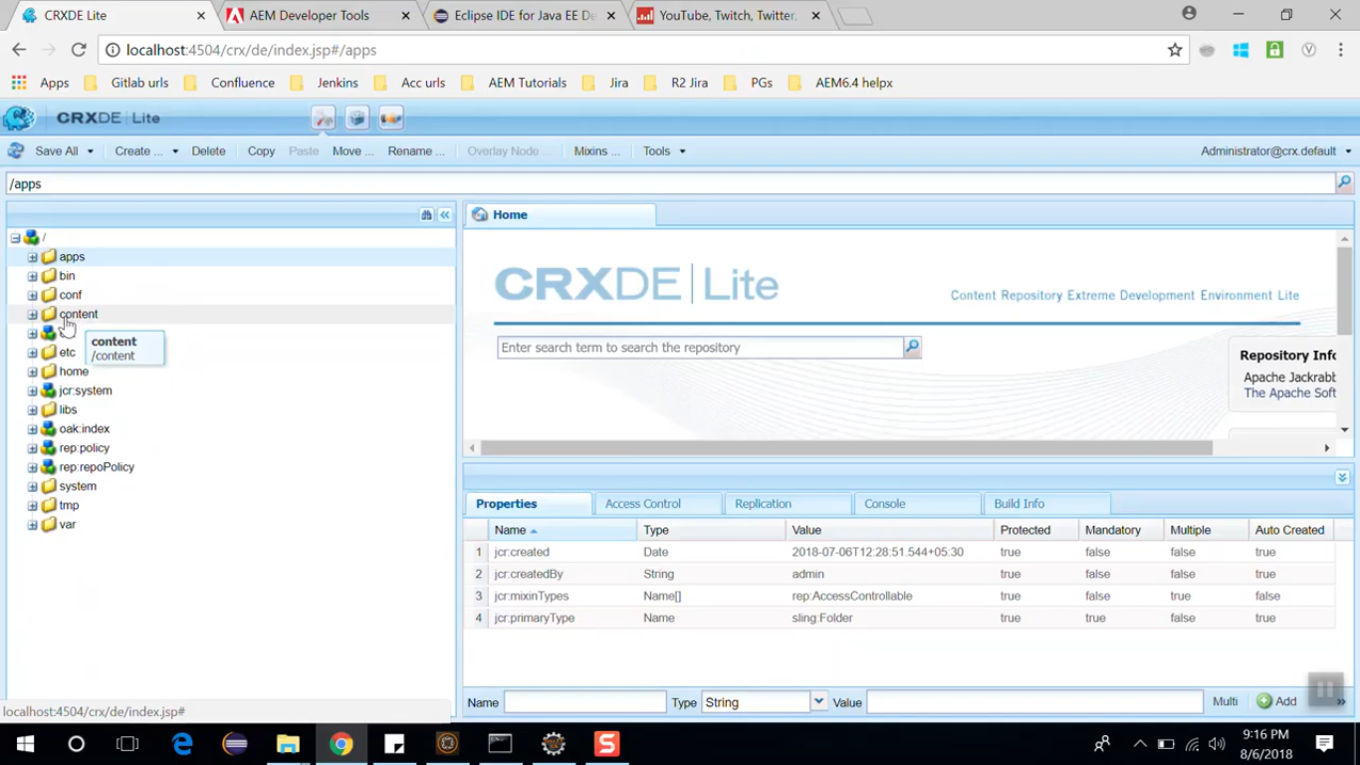

Figure 1 - ui.apps folder Figure 2 - ui.content folder

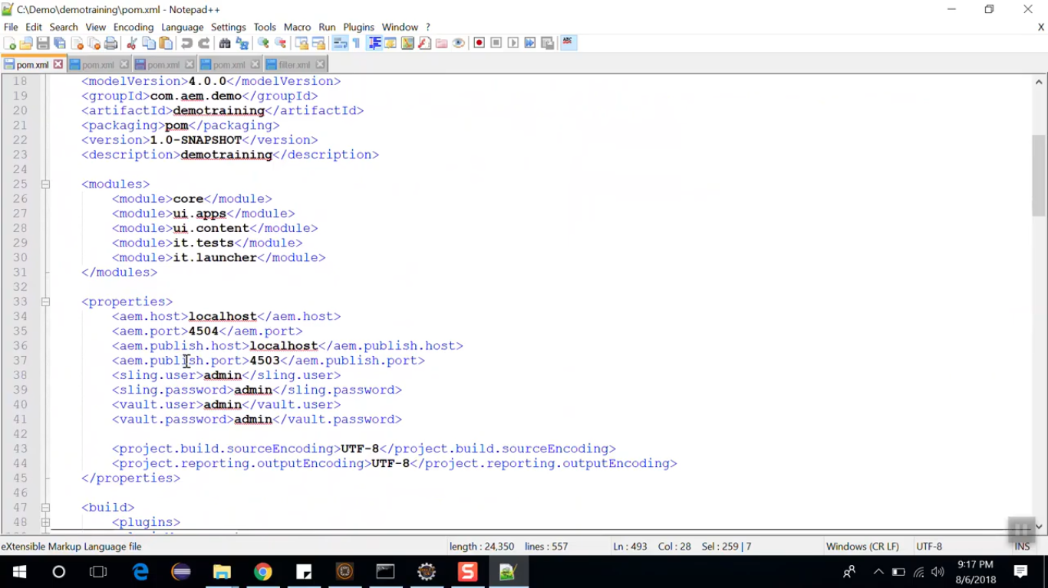

In above POM.xml, you can see all the modules and the global properties which are setup to deploy the local AEM instance. These properties can be overridden via command line when deploying to higher environments.

POM.xml also includes dependency management section. It lists all the dependencies and all the versions API to be used in the project.

One of the key dependency is uber.jar file. This is special JAR provided by Adobe which includes all the AEM API structures – single dependency entry for the version of AEM

